

0000.doc

Prepared by: John FitzGerald
Date last modified: Thursday, February 03, 2011
Project Manager: Paul Arnold

Issue | Date | Changes | By
A | 25-Mar-10 | New Document | JF
B | 8-Apr-10 | corrected signed char, edited Excel date / time, manifold htr now ACTIVE in ModeStandby, temperature to use degrees Celsius, corrected message length to use two bytes. Added detail to SetServoOpenLimit, SetServoClosedLimit, SetManifoldHeaterTemperature, SetPitotHeaterTemperature commands. | JF
C | 29-Apr-10 | Modified power calculations to use <value> / 4095 * n.  Added detail to SetDateTime. Changed numbering of bytes in example serial messages to start from zero to be the same as in tables. Added LCDAReport, LCDBReport and Text messages and example AgentID codes. Status.System bits 27 and 26 revised. Additional Status.System bits defined. Added new section OPERATING CYCLE. Added new command ActionSaveSettings. | JF
D | 24-May-10 | Added Status.System bits 9, 10 ,11 and 12 and 13, 14, 15 and 16. Minor edits. Added new Spectrum message and details of data expansion. Added new commands 1..8 (ActionLCDASendSpectrumG etc.) | JF
E | 12-Aug-10 | Corrected ADPCM_Decode Fn (StepSizeTable). Added ADPCM test spectrum as byte array. Reversed P and T in LCDA/BReport message to match actual software implementation. Added Status.System bits 17, 18, 19, 20, 21, 22, 23, 24 and 25.  Corrected message length examples for LCD A Status.  Added new section, "Data Saved by ANACONDA". Updated and revised some of the general text with reference to Display software F and System software D. | JF
F | 6-Oct-10 | Added GPSTime to "Data Saved by ANACONDA" with reference to Display software G and System software E.  Corrected GPS Altitude from metres to units of "Feet" | JF
G | 19-Jan-11 | Added new section, "Reprogramming using serial comms" with reference to Display software H and System software F | JF

1 Serial Communication 5
2 General Message Timing 5
3 General Message Handling 5
3.1 Handshaking 5
3.2 Time 5
3.3 Convert EPOCH (UTC) time in Excel 5
3.3.1 Using a Time Zone Offset 5
3.3.2 Without Time Zone Offset 6
3.4 Byte ordering 6
3.4.1 8 bit BYTES 6
3.4.2 16 bit SHORTS 6
3.4.3 32 bit INTEGERS 6
3.4.4 32 bit packed unsigned INTEGER 6
3.4.5 32 bit FLOATS 7
3.4.6 Strings 7
3.5 Variable Sizes 7
3.5.1 char (Byte) 7
3.5.2 short 7
3.5.3 int 7
3.5.4 long 8
3.5.5 long long 8
3.6 Number Formats 8
3.6.1 Hexadecimal 8
3.6.2 Decimal 8
3.7 Excel Worksheet Limits 8
4 Data Sent To ANACONDA 8
4.1 Message Structure 8
4.2 Table of Message Types 9
4.3 GPS Data 11
4.4 ModeIdle 12
4.5 ModeSearch1 13
4.6 ModeSearch2 13
4.7 ModeSearch3 13
4.8 ModeSearch4 14
4.9 ModeStandby 14
4.10 ModeAirframe 15
4.11 ModePod 15
4.12 ActionDelete1 16
4.13 ActionDelete2 16
4.14 ActionDelete3 16
4.15 ActionDelete4 16
4.16 SetDateTime 16
4.17 SetServoOpenLimit 17
4.18 SetServoClosedLimit 17
4.19 SetManifoldHeaterTemperature 17
4.20 SetPitotHeaterTemperature 18
4.21 ActionSaveSettings 18
4.22 ActionLCDASendSpectrumG 18
4.23 ActionLCDASendSpectrumH 18
4.24 ActionLCDBSendSpectrumG 18
4.25 ActionLCDBSendSpectrumH 18
4.26 ActionLCDAStopSpectrumG 18
4.27 ActionLCDAStopSpectrumH 19
4.28 ActionLCDBStopSpectrumG 19
4.29 ActionLCDBStopSpectrumH 19
4.30 DebugPermitDebug 19
4.31 DebugForbidDebug 19
4.32 DebugServoOpen 19
4.33 DebugServoClosed 19
4.34 DebugManifoldHeaterOn 19
4.35 DebugManifoldHeaterOff 19
4.36 DebugPitotHeaterOn 19
4.37 DebugPitotHeaterOff 20
4.38 DebugPumpsOn 20
4.39 DebugPumpsOff 20
4.40 DebugValves1Open 20
4.41 DebugValves2Open 20
4.42 DebugValves3Open 20
4.43 DebugValves4Open 20
4.44 DebugValves1Closed 20
4.45 DebugValves2Closed 21
4.46 DebugValves3Closed 21
4.47 DebugValves4Closed 21
4.48 DebugValvesAllClosed 21
4.49 DebugWriteTestFiles 21
4.50 DebugWriteTestFileLCDA / Reprogram LCDA 21
4.51 DebugWriteTestFileLCDB / Reprogram LCDB 21
4.52 DebugWriteTestFileSYS 21
4.53 DebugResetLCDA 22
4.54 DebugResetLCDB 22
4.55 DebugReleaseResetLCDA 22
4.56 DebugReleaseResetLCDB 22
5 Data Sent From ANACONDA 22
5.1 Message Structure 22
5.2 Table of Message Types 23
5.3 Status 25
5.3.1 LCDA Status 25
5.3.2 LCDB Status 26
5.3.3 ANACONDA Mode 26
5.3.4 Manifold Heater 26
5.3.5 Pitot Heater 26
5.3.6 Power 26
5.3.7 System 27
5.4 LCDAReport 28
5.4.1 PTValues 29
5.4.2 No Agents 29
5.4.3 One or more agents reported 30
5.5 LCDBReport 30
5.6 Text 30
5.7 Spectra 31
5.7.1 Spectrum Message Data Format 31
5.8 ADPCM_Decode 32
5.8.1 Spectral Source Data 32
5.8.2 ADPCM Nibble Data 33
5.8.3 ADPCM Byte Data 35
5.8.4 Reconstructed Data 36
5.8.5 Original and Reconstruction graphed 38
5.8.6 ADPCM_Decode Function 39
5.9 LCDA G Spectrum 40
5.10 LCDA H Spectrum 40
5.11 LCDB G Spectrum 40
5.12 LCDB H Spectrum 40
6 Data Saved by ANACONDA 41
6.1 Data Logging 41
6.2 File Description 41
6.3 File Record Format 41
6.3.1 Version 3 41
6.3.2 Version 2 43
6.3.3 Version 1 44
7 Centigrade to Fahrenheit Table 45
8 Agent Identity 46
8.1 Example AgentID codes 46
9 Operating Cycle 47
9.1 Simple Cycle 48
9.2 Simple Cycle with newly crippled LCDB 48
9.3 Limp Home Cycle 48
10 Reprogramming using serial comms 48
10.1 Introduction 48
10.2 Reprogramming the System PCB 49
10.3 Reprogramming the Display PCBs 54

Serial Communication

Uses 115200 / 8-N-1 asynchronous data.
RS232 levels

General Message Timing

The ANACONDA will buffer received messages which may be sent to it at any time.

The ANACONDA is likely to send messages at the end of each processing cycle. Probably about twice per second. See Operating Cycle.

General Message Handling

Handshaking

Although the ANACONDA interface includes two signals for hardware handshaking neither hardware nor software handshaking is used.

Time

Time will be handled in ANACONDA using the ISO C time_t type where the time_t is a signed integer (32 bits wide) which represents the number of seconds since the start of the Unix epoch: midnight UTC of January 1, 1970.

Note : (32 bit time_t wraps around negative in 2038 - not deemed to be a problem for this project).

Convert EPOCH (UTC) time in Excel

Here is the formula to convert epoch time to a standard format in Excel. After using the formula, you will need to format the cell for date and time.

Using a Time Zone Offset

=(((E2-(6*3600))/86400)+25569)

• E2 = cell reference
• 6 = Time zone Offset
• 3600 = Number of seconds in an hour
• 86400 = Number of seconds in a year
• 25569 = Excel hack because excel counts epoch from 1/1/1900 and most others start at 1/1/1970.

Without Time Zone Offset

=(((E2)/86400)+25569)

Note that Excel can normally format a cell as Time or Date but not both together.

However, while there is no default option to do both in Excel, the "custom" format option using the format code 'mm/dd/yyyy hh:mm:ss' can be used to get this result.

Byte ordering

8 bit BYTES
ANACONDA transmits bytes integrally.

16 bit SHORTS
ANACONDA transmits 16 bit shorts least significant byte first. For example the word value 0x1234 is sent as,
34 12 and will be stored internally as,

Address | n | n+1
Data | 34 | 12

32 bit INTEGERS
ANACONDA transmits 32 bit integers least significant byte first. For example the value 0x12345678 is sent as,
78 56 34 12 and will be stored internally as,

Address | n | n+1 | n+2 | n+3
Data | 78 | 56 | 34 | 12

32 bit packed unsigned INTEGER
Some messages may pack smaller types into a 32 bit packed unsigned INTEGER.

For example decimal values 1100 and 1800 may be packed as

Bits 31..16 | Bits 15..0
0x044C | 0x0708
This value 0x044C0708 is sent as,
08 07 4C 04.

The packed types may be signed. They are treated as above.

For example decimal values -3 and -1000 may be packed as

Bits 31..16 | Bits 15..0
0xFFFD | 0xFC18
This value 0xFFFDFC18 is sent as,
18 FC FD FF.

32 bit FLOATS
ANACONDA transmits 32 bit floats least significant byte first. For example the float value 0xC1480000 is sent as,
00 00 48 C1 and will be stored internally as,

Address | n | n+1 | n+2 | n+3
Data | 00 | 00 | 48 | C1

Strings
ANACONDA transmits strings in literal character order. For example JF1 is sent as

Address | n | n+1 | n+2
Data | 4A | 46 | 31

Variable Sizes

Where variable types are used in this document, their sizes are as described below.

char (Byte)

SIZE 8 bits | MIN | MAX
UNSIGNED | 0 | 255
SIGNED | (-127 - 1) | 127

short

SIZE 16 bits | MIN | MAX
UNSIGNED | 0 | 65535
SIGNED | (-32767 - 1) | 32767

int

SIZE 32 bits | MIN | MAX
UNSIGNED | 0 | 4294967295
SIGNED | (-2147483647 - 1) | 2147483647

long

SIZE 32 bits | MIN | MAX
UNSIGNED | 0 | 4294967295
SIGNED | (-2147483647 - 1) | 2147483647

long long

SIZE 64 bits | MIN | MAX
UNSIGNED | 0 | 18446744073709551615
SIGNED | (-9223372036854775807 - 1) | 9223372036854775807

Number Formats

Hexadecimal

A hexadecimal integer begins with the 0 digit followed by either an x or X, followed by any combination of the digits 0 through 9 and the letters a through f or A through F. The letters A (or a) through F (or f) represent the values 10 through 15, respectively.

Decimal

A decimal integer contains any of the digits 0 through 9. The first digit cannot be 0.

(Integers beginning with the digit 0 are interpreted as an octal integer rather than as a decimal integer. Octal integers are not expected to be used.)

Floating point values may be used. Single precision is expected to be used internally.

Excel Worksheet Limits

Worksheet size 65,536 rows by 256 columns
Column width 255 characters

Data Sent To ANACONDA

Message Structure

Byte | Field | Type | Value
0 | Sync Byte | Byte | 0x7E
1 | Sync Byte | Byte | 0x7E
2 | Message Type | Byte
3-4 | Data Length | unsigned Short
5...n | Data | Bytes
Len-1 | Checksum | Byte

Two sync bytes "0x7E 0x7E" will always precede the Message Type byte.
Data Length indicates the number of bytes to follow not including the Checksum byte. Range 0..65535.
The Checksum byte is calculated as the modulo 256 (byte remainder) of the unsigned sum of byte values beginning with the message type and including Data Length bytes and Data bytes.

For example -

The command "ModeIdle" (command 20 _{decimal} ) which contains no Data field would be sent as,
Sync | Sync | Type | Length | Length | Chk
0x7E | 0x7E | 0x14 | 0x00 | 0x00 | 0x14
1 | 2 | 3 | 4 | 5 | 6

Table of Message Types

Message types 1..127 are reserved for data sent to ANACONDA.

Message types 128..255 are reserved for data sent by ANACONDA. Please see separate section for these.

Index ₁₀ | Index ₁₆ | Message Type
0 | 00 | Type zero is never used.
1 | 01 | ActionLCDASendSpectrumG
2 | 02 | ActionLCDASendSpectrumH
3 | 03 | ActionLCDBSendSpectrumG
4 | 04 | ActionLCDBSendSpectrumH
5 | 05 | ActionLCDAStopSpectrumG
6 | 06 | ActionLCDAStopSpectrumH
7 | 07 | ActionLCDBStopSpectrumG
8 | 08 | ActionLCDBStopSpectrumH
9 | 09
10 | 0A
11 | 0B
12 | 0C
13 | 0D
14 | 0E
15 | 0F
16 | 10 | GPS Data
17 | 11
18 | 12
19 | 13
20 | 14 | ModeIdle
21 | 15 | ModeSearch1
22 | 16 | ModeSearch2
23 | 17 | ModeSearch3
24 | 18 | ModeSearch4
25 | 19 | ModeStandby
26 | 1A | ModeAirframe
27 | 1B | ModePod
28 | 1C
29 | 1D
30 | 1E
31 | 1F | ActionDelete1
32 | 20 | ActionDelete2
33 | 21 | ActionDelete3
34 | 22 | ActionDelete4
35 | 23
36 | 24
37 | 25
38 | 26
39 | 27
40 | 28 | SetDateTime
41 | 29 | SetServoOpenLimit
42 | 2A | SetServoClosedLimit
43 | 2B | SetManifoldHeaterTemperature
44 | 2C | SetPitotHeaterTemperature
45 | 2D | ActionSaveSettings
46 | 2E
47 | 2F
48 | 30
49 | 31
50 | 32
51 | 33
52 | 34
53 | 35
54 | 36
55 | 37
56 | 38
57 | 39
58 | 3A
59 | 3B
60 | 3C
61 | 3D
62 | 3E | DebugPermitDebug
63 | 3F | DebugForbidDebug
64 | 40 | DebugServoOpen
65 | 41 | DebugServoClosed
66 | 42 | DebugManifoldHeaterOn
67 | 43 | DebugManifoldHeaterOff
68 | 44 | DebugPitotHeaterOn
69 | 45 | DebugPitotHeaterOff
70 | 46 | DebugPumpsOn
71 | 47 | DebugPumpsOff
72 | 48 | DebugValves1Open
73 | 49 | DebugValves2Open
74 | 4A | DebugValves3Open
75 | 4B | DebugValves4Open
76 | 4C | DebugValves1Closed
77 | 4D | DebugValves2Closed
78 | 4E | DebugValves3Closed
79 | 4F | DebugValves4Closed
80 | 50 | DebugValvesAllClosed
81 | 51 | DebugWriteTestFiles
82 | 52 | DebugWriteTestFileLCDA
83 | 53 | DebugWriteTestFileLCDB
84 | 54 | DebugWriteTestFileSYS
85 | 55
86 | 56
87 | 57
88 | 58
89 | 59
90 | 5A
91 | 5B
92 | 5C
93 | 5D
94 | 5E
95 | 5F
96 | 60 | DebugResetLCDA
97 | 61 | DebugResetLCDB
98 | 62 | DebugReleaseResetLCDA
99 | 63 | DebugReleaseResetLCDB
100 | 64
101 | 65
102 | 66
103 | 67
104 | 68
105 | 69
106 | 6A
107 | 6B
108 | 6C
109 | 6D
110 | 6E
111 | 6F
112 | 70
113 | 71
114 | 72
115 | 73
116 | 74
117 | 75
118 | 76
119 | 77
120 | 78
121 | 79
122 | 7A
123 | 7B
124 | 7C
125 | 7D
126 | 7E
127 | 7F

GPS Data

Byte | Field | Type | Value
0 | Sync Byte | Byte | 0x7E
1 | Sync Byte | Byte | 0x7E
2 | Message Type | Byte | 16
3-4 | Data Length | unsigned Short | 15
5 | Data Valid | Byte | 1=Valid, 0=Invalid
6-9 | time_t | Integer | The number of seconds since midnight of January 1, 1970.
10-13 | GPS Lat | Integer | GPS Lat  (LSB=1E-6 deg, range +90 to –90 deg, +=North Lat)
14-17 | GPS Lon | Integer | GPS Lon  (LSB=1E-6 deg, range +180 to –180 deg, +=East Lon)
18-19 | GPS Altitude | Short | GPS Altitude (LSB=1 foot)
20 | Checksum | Byte | Checksum

ModeIdle

Sync | Sync | Type | Length | Length | Chk
0x7E | 0x7E | 0x14 | 0x00 | 0x00 | 0x14
0 | 1 | 2 | 3 | 4 | 5

Configures ANACONDA as tabulated.

Mode IDLE | Status | Data Logged
Communications with Host | ACTIVE
Data Logging | ACTIVE | none
Pitot Heater | OFF
Manifold Heater | OFF
Pitot Valve | CLOSED
Detector | OFF
Detector Recirculation Fan | OFF
Detector Inlet Fan | OFF
Detector Pulser | OFF
Sample Retention System | OFF

ModeSearch1

Sync | Sync | Type | Length | Length | Chk
0x7E | 0x7E | 0x15 | 0x00 | 0x00 | 0x15
0 | 1 | 2 | 3 | 4 | 5

Mode SEARCH | Status | Data Logged
Communications with Host | ACTIVE
Data Logging | ACTIVE | GPS + IMS Data
Pitot Heater | ACTIVE
Manifold Heater | ACTIVE
Pitot Valve | OPEN
Detector | ON
Detector Recirculation Fan | ON
Detector Inlet Fan | ON
Detector Pulser | ACTIVE
Sample Retention System | ACTIVE | see note below

note - Using sample tubes 1A and 1B.

ModeSearch2

Sync | Sync | Type | Length | Length | Chk
0x7E | 0x7E | 0x16 | 0x00 | 0x00 | 0x16
0 | 1 | 2 | 3 | 4 | 5

As ModeSearch1 but using sample tubes 2A and 2B.

ModeSearch3

Sync | Sync | Type | Length | Length | Chk
0x7E | 0x7E | 0x17 | 0x00 | 0x00 | 0x17
0 | 1 | 2 | 3 | 4 | 5

As ModeSearch1 but using sample tubes 3A and 3B.

ModeSearch4

Sync | Sync | Type | Length | Length | Chk
0x7E | 0x7E | 0x18 | 0x00 | 0x00 | 0x18
0 | 1 | 2 | 3 | 4 | 5

As ModeSearch1 but using sample tubes 4A and 4B.

ModeStandby

Sync | Sync | Type | Length | Length | Chk
0x7E | 0x7E | 0x19 | 0x00 | 0x00 | 0x19
0 | 1 | 2 | 3 | 4 | 5

Mode STANDBY | Status | Data Logged
Communications with Host | ACTIVE
Data Logging | ACTIVE | GPS + IMS Data
Pitot Heater | ACTIVE
Manifold Heater | ACTIVE
Pitot Valve | CLOSED
Detector | ON
Detector Recirculation Fan | ON
Detector Inlet Fan | OFF
Detector Pulser | OFF
Sample Retention System | OFF

ModeAirframe

Sync | Sync | Type | Length | Length | Chk
0x7E | 0x7E | 0x1A | 0x00 | 0x00 | 0x1A
0 | 1 | 2 | 3 | 4 | 5

Mode AIRFRAME | Status | Data Logged
Communications with Host | ACTIVE
Data Logging | ACTIVE | GPS*+ IMS Data
Pitot Heater | ACTIVE**
Manifold Heater | ACTIVE
Pitot Valve | OPEN
Detector | ON
Detector Recirculation Fan | ON
Detector Inlet Fan | ON
Detector Pulser | ACTIVE
Sample Retention System | OFF

* GPS data will only be present when the chemical module is inside the pod and the chemical module / pod are connected to the UAV. Otherwise, for ground tests done BEFORE the chemical module / pod is attached to the UAV, there will not be any GPS data.

ModePod

Sync | Sync | Type | Length | Length | Chk
0x7E | 0x7E | 0x1B | 0x00 | 0x00 | 0x1B
0 | 1 | 2 | 3 | 4 | 5

Mode POD | Status | Data Logged
Communications with Host | ACTIVE
Data Logging | ACTIVE | None
Pitot Heater | ACTIVE
Manifold Heater | ACTIVE
Pitot Valve | CLOSED
Detector | OFF
Detector Recirculation Fan | ON
Detector Inlet Fan | OFF
Detector Pulser | OFF
Sample Retention System | OFF

ActionDelete1

Deletes any files recorded during ModeSearch1. Not implemented - files can be deleted in an SD card reader connected to a PC running Windows.

ActionDelete2

Deletes any files recorded during ModeSearch2. Not implemented - files can be deleted in an SD card reader connected to a PC running Windows.

ActionDelete3

Deletes any files recorded during ModeSearch3. Not implemented - files can be deleted in an SD card reader connected to a PC running Windows.

ActionDelete4

Deletes any files recorded during ModeSearch4. Not implemented - files can be deleted in an SD card reader connected to a PC running Windows.

SetDateTime

Sets date and time according to time_t value embedded in command. ANACONDA expects to see UTC time in the SetDateTime message using the ISO C time_t type where the time_t is a signed integer (32 bits wide).

Ignoring small differences such as leap seconds, UTC, ZULU and GMT are equivalent.

Sync | Sync | Type | Length | Length | time_t |  |  |  | Chk
0x7E | 0x7E | 0x28 | 0x04 | 0x00 | lsbyte | - | - | msbyte | 0xnn
0 | 1 | 2 | 3 | 4 | 5 | 6 | 7 | 8 | 9

SetServoOpenLimit

Sets the value used for servo drive pulse width to control open position (Saved in non-volatile memory if ActionSaveSettings command is issued).

Sync | Sync | Type | Length | Length | Pulse | Width | Chk
0x7E | 0x7E | 0x29 | 0x02 | 0x00 | lsbyte | msbyte | 0xnn
0 | 1 | 2 | 3 | 4 | 5 | 6 | 7

Note the data payload signed SHORT sets the pulse width in microseconds to be used for the valve open position.
Typical values will be in the range 1000 to 2000 (1ms..2ms).

SetServoClosedLimit

Sets the value used for servo drive pulse width to control closed position (Saved in non-volatile memory if ActionSaveSettings command is issued).

Sync | Sync | Type | Length | Length | Pulse | Width | Chk
0x7E | 0x7E | 0x2A | 0x02 | 0x00 | lsbyte | msbyte | 0xnn
0 | 1 | 2 | 3 | 4 | 5 | 6 | 7

Note the data payload signed SHORT sets the pulse width in microseconds to be used for the valve open position.
Typical values will be in the range 1000 to 2000 (1ms..2ms).

SetManifoldHeaterTemperature

Sets the value used for the Manifold Heater temperature (Saved in non-volatile memory if ActionSaveSettings command is issued).

Sync | Sync | Type | Length | Length | Temperature | Temperature | Chk
0x7E | 0x7E | 0x2B | 0x02 | 0x00 | lsbyte | msbyte | 0xnn
0 | 1 | 2 | 3 | 4 | 5 | 6 | 7

Note the data payload signed SHORT sets the target heater temperature in degrees C.
A typical value might be +10. Temperatures below zero can also be requested.

SetPitotHeaterTemperature

Sets the value used for the Pitot Heater temperature (Saved in non-volatile memory if ActionSaveSettings command is issued).

Sync | Sync | Type | Length | Length | Temperature | Temperature | Chk
0x7E | 0x7E | 0x2C | 0x02 | 0x00 | lsbyte | msbyte | 0xnn
0 | 1 | 2 | 3 | 4 | 5 | 6 | 7

Note the data payload signed SHORT sets the target heater temperature in degrees C.
A typical value might be +10. Temperatures below zero can also be requested.

ActionSaveSettings

Save the current valid servo limits and manifold and pitot heater temperature settings in non-volatile memory.
Implemented in System software revision D onwards.

ActionLCDASendSpectrumG
Requests LCD to send spectrum message for spectrum. Corresponding bit is set in Status message System variable.

ActionLCDASendSpectrumH
Requests LCD to send spectrum message for spectrum. Corresponding bit is set in Status message System variable.

ActionLCDBSendSpectrumG
Requests LCD to send spectrum message for spectrum. Corresponding bit is set in Status message System variable.

ActionLCDBSendSpectrumH
Requests LCD to send spectrum message for spectrum. Corresponding bit is set in Status message System variable.

ActionLCDAStopSpectrumG
Requests LCD to stop sending spectrum message for spectrum. Corresponding bit is cleared in Status message System variable.

ActionLCDAStopSpectrumH
Requests LCD to stop sending spectrum message for spectrum. Corresponding bit is cleared in Status message System variable.

ActionLCDBStopSpectrumG
Requests LCD to stop sending spectrum message for spectrum. Corresponding bit is cleared in Status message System variable.

ActionLCDBStopSpectrumH
Requests LCD to stop sending spectrum message for spectrum. Corresponding bit is cleared in Status message System variable.

DebugPermitDebug

Allows Debug commands to be actioned.

DebugForbidDebug

Prevents Debug commands from being actioned.

DebugServoOpen

Force the pitot valve servo to the open position.

DebugServoClosed

Force the pitot valve servo to the closed position.

DebugManifoldHeaterOn

Force the manifold heater to power ON.

DebugManifoldHeaterOff

Force the manifold heater to power OFF.

DebugPitotHeaterOn

Force the pitot heater to power ON.

DebugPitotHeaterOff

Force the pitot heater to power ON.

DebugPumpsOn

Force the pumps to power ON. (This command may require one or more flow paths to be open to avoid pumping into a closed pneumatic path.)

DebugPumpsOff

Force the pumps to power OFF.

DebugValves1Open

De-energize any other open valves Energize the nominated pair of valves to provide flow paths through the two nominated sample retention tubes. (Tubes are always opened in pairs. One from the A group and one from the B group. This avoids the A or B pump from trying to pump into a closed pneumatic path. The pumps are always energized together.)

DebugValves2Open

De-energize any other open valves Energize the nominated pair of valves to provide flow paths through the two nominated sample retention tubes. (Tubes are always opened in pairs. One from the A group and one from the B group. This avoids the A or B pump from trying to pump into a closed pneumatic path. The pumps are always energized together.)

DebugValves3Open

De-energize any other open valves Energize the nominated pair of valves to provide flow paths through the two nominated sample retention tubes. (Tubes are always opened in pairs. One from the A group and one from the B group. This avoids the A or B pump from trying to pump into a closed pneumatic path. The pumps are always energized together.)

DebugValves4Open

De-energize any other open valves Energize the nominated pair of valves to provide flow paths through the two nominated sample retention tubes. (Tubes are always opened in pairs. One from the A group and one from the B group. This avoids the A or B pump from trying to pump into a closed pneumatic path. The pumps are always energized together.)

DebugValves1Closed

De-energize the nominated valves to close the flow paths through the nominated pair of sample retention tubes.

DebugValves2Closed

De-energize the nominated valves to close the flow paths through the nominated pair of sample retention tubes.

DebugValves3Closed

De-energize the nominated valves to close the flow paths through the nominated pair of sample retention tubes.

DebugValves4Closed

De-energize the nominated valves to close the flow paths through the nominated pair of sample retention tubes.

DebugValvesAllClosed

De-energize all the nominated valves to close the flow paths through all sample retention tubes.
(If no valves are open, the pumps will be switched OFF to avoid pumping into a closed pneumatic path.)

DebugWriteTestFiles

Delete any existing Test Files on the memory cards on the LCDA, LCDB and the System PCBs and write new ones if possible. Not implemented - a test file can be written by choosing any operating mode except MODE_IDLE.

DebugWriteTestFileLCDA / Reprogram LCDA

Delete any existing Test File on the memory card on the LCDA PCB and write a new one if possible. Not implemented - a test file can be written by choosing any operating mode except MODE_IDLE.

Note that this command is now used to configure the system to reprogram LCD A.

DebugWriteTestFileLCDB / Reprogram LCDB

Delete any existing Test File on the memory card on the LCDB PCB and write a new one if possible. Not implemented - a test file can be written by choosing any operating mode except MODE_IDLE.

Note that this command is now used to configure the system to reprogram LCD B.

DebugWriteTestFileSYS

Delete any existing Test File on the memory card on the System PCB and write a new one if possible. Not implemented - the System PCB does not currently (rev D) support data logging.

DebugResetLCDA

Assert the reset input on the LCDA PCB.

DebugResetLCDB

Assert the reset input on the LCDB PCB.

DebugReleaseResetLCDA

De-assert the reset input on the LCDA PCB.

DebugReleaseResetLCDB

De-assert the reset input on the LCDB PCB.

Data Sent From ANACONDA

Message Structure

Byte | Field | Type | Value
0 | Sync Byte | Byte | 0x7E
1 | Sync Byte | Byte | 0x7E
2 | Message Type | Byte
3-4 | Data Length | unsigned Short
5...n | Data | Bytes
Len-1 | Checksum | Byte

Two sync bytes "0x7E 0x7E" will always precede the Message Type byte.
Data Length indicates the number of bytes to follow not including the Checksum byte. Range 0..65535.
The Checksum byte is calculated as the modulo 256 (byte remainder) of the unsigned sum of byte values beginning with the message type and including Data Length bytes and Data bytes.
For example,
Sync | Sync | Type | Length | Length |  | Chk
0x7E | 0x7E | 0x80 | 0x04 | 0x00 | Data | 0xnn
0 | 1 | 2 | 3 | 4 | 5-8 | 9

Table of Message Types

Message types 128..255 are reserved for data sent by ANACONDA.

Message types 0..127 are reserved for data sent to ANACONDA. Please see separate section for these.

Index ₁₀ | Index ₁₆ | Message Type
128 | 80 | Status
129 | 81 | LCDAReport
130 | 82 | LCDBReport
131 | 83 | Text
132 | 84 | LCDA G Spectrum
133 | 85 | LCDA H Spectrum
134 | 86 | LCDB G Spectrum
135 | 87 | LCDB H Spectrum
136 | 88
137 | 89
138 | 8A
139 | 8B
140 | 8C
141 | 8D
142 | 8E
143 | 8F
144 | 90
145 | 91
146 | 92
147 | 93
148 | 94
149 | 95
150 | 96
151 | 97
152 | 98
153 | 99
154 | 9A
155 | 9B
156 | 9C
157 | 9D
158 | 9E
159 | 9F
160 | A0
161 | A1
162 | A2
163 | A3
164 | A4
165 | A5
166 | A6
167 | A7
168 | A8
169 | A9
170 | AA
171 | AB
172 | AC
173 | AD
174 | AE
175 | AF
176 | B0
177 | B1
178 | B2
179 | B3
180 | B4
181 | B5
182 | B6
183 | B7
184 | B8
185 | B9
186 | BA
187 | BB
188 | BC
189 | BD
190 | BE
191 | BF
192 | C0
193 | C1
194 | C2
195 | C3
196 | C4
197 | C5
198 | C6
199 | C7
200 | C8
201 | C9
202 | CA
203 | CB
204 | CC
205 | CD
206 | CE
207 | CF
208 | D0
209 | D1
210 | D2
211 | D3
212 | D4
213 | D5
214 | D6
215 | D7
216 | D8
217 | D9
218 | DA
219 | DB
220 | DC
221 | DD
222 | DE
223 | DF
224 | E0
225 | E1
226 | E2
227 | E3
228 | E4
229 | E5
230 | E6
231 | E7
232 | E8
233 | E9
234 | EA
235 | EB
236 | EC
237 | ED
238 | EE
239 | EF
240 | F0
241 | F1
242 | F2
243 | F3
244 | F4
245 | F5
246 | F6
247 | F7
248 | F8
249 | F9
250 | FA
251 | FB
252 | FC
253 | FD
254 | FE
255 | FF

Status

Reports the following.

Byte | Field | Type | Value
0 | Sync Byte | Byte | 0x7E
1 | Sync Byte | Byte | 0x7E
2 | Message Type | Byte | 0x80
3-4 | Data Length | unsigned Short
5-8 | time_t | Integer | The number of seconds since midnight of January 1, 1970.
9-12 | LCDA Status | packed unsigned Integer | see description of fields below
13-16 | LCDB Status | packed unsigned Integer | see description of fields below
17-20 | ANACONDA Mode | packed unsigned Integer | see description of fields below
21-24 | Manifold Heater | packed unsigned Integer | see description of fields below
25-28 | Pitot Heater | packed unsigned Integer | see description of fields below
29-32 | Power | packed unsigned Integer | see description of fields below
33-36 | System | unsigned Integer | see description of bits below
37 | Checksum | Byte | Checksum

LCDA Status
packed unsigned Integer

Zero when no faults or errors - other values to be defined. Currently not implemented - The status of LCDA is reported in its messages ... which may cease if it fails. This variable is always zero.

LCDB Status
packed unsigned Integer

Zero when no faults or errors - other values to be defined. Currently not implemented - The status of LCDA is reported in its messages ... which may cease if it fails. This variable is always zero.

ANACONDA Mode
packed unsigned Integer

Bits 31..24 | Bits 23..16 | Bits 15..8 | Bits 7 .. 0
LCDA Current Mode | LCDA Requested Mode | LCDB Current Mode | LCDB Requested Mode

Manifold Heater
packed unsigned Integer

Bits 31..16 | Bits 15..0
Target Temperature | Actual Temperature

The temperature is represented as a signed Short value to the nearest whole degree centigrade.

Pitot Heater
packed unsigned Integer

Bits 31..16 | Bits 15..0
Target Temperature | Actual Temperature

The temperature is represented as a signed Short value to the nearest whole degree centigrade.

Power
packed unsigned Integer

Bits 31..16 | Bits 15..0
Volts | Amps

The supply voltage is measured on the System PCB using a 12 bit ADC with a full scale of 102.4V.
The supply current including the current into the heaters and all other loads is measured on the System PCB using a 12 bit ADC with a full scale of 4.096A.

So for example, a supply of 27.5V and current of 1.8A and would be indicated by values of,

1100 and 1800 packed as

Bits 31..16 | Bits 15..0
0x044c | 0x0708

where voltage is < value > / 4095 * 102.4 and current is < value > / 4095 * 4.096.

Note that the nominal +28V supply passes through a series schottky diode as well as various protection and measurement devices. Thus the indicated (and actual) supply to the System PCB may be a little less than the supply input voltage. An indicated voltage up to 0.5 volts less than the nominal supply is normal and does not indicate any fault. A measure of the instantaneous power used by ANACONDA can be found by multiplying the voltage and current readings.

System
unsigned Integer

Bit values indicate as tabulated below.

 | Bit | Meaning
0x80000000 | 31 | Pitot Valve | 1 = OPEN, 0 = CLOSED
0x40000000 | 30 | Manifold Heater | 1 = ON, 0 = OFF
0x20000000 | 29 | Pitot Heater | 1 = ON, 0 = OFF
0x10000000 | 28 | SRS Pumps Supply | 1 = ON, 0 = OFF
0x08000000 | 27 | SRS Valves Supply | 1 = ON, 0 = OFF
0x04000000 | 26 | SRS Valves Drive | 1 = FULL, 0 = LOW POWER HOLDING
0x02000000 | 25 | System Information | 1 = send information (cleared when actioned by System)
0x01000000 | 24 | LCDB Information | 1 = send information (cleared when actioned by System)
0x00800000 | 23 | LCDA Information | 1 = send information (cleared when actioned by System)
0x00400000 | 22 | LCDB Test File | 1 = create test file (cleared when actioned by System)
0x00200000 | 21 | LCDA Test File | 1 = create test file (cleared when actioned by System)
0x00100000 | 20 | Delete 4 | 1 = delete SRS4 file(s) (cleared when actioned by System)
0x00080000 | 19 | Delete 3 | 1 = delete SRS3 file(s) (cleared when actioned by System)
0x00040000 | 18 | Delete 2 | 1 = delete SRS2 file(s) (cleared when actioned by System)
0x00020000 | 17 | Delete 1 | 1 = delete SRS1 file(s) (cleared when actioned by System)
0x00010000 | 16 | LCDB H Spectrum | 1 = send spectrum message
0x00008000 | 15 | LCDA H Spectrum | 1 = send spectrum message
0x00004000 | 14 | LCDB G Spectrum | 1 = send spectrum message
0x00002000 | 13 | LCDA G Spectrum | 1 = send spectrum message
0x00001000 | 12 | LCDB Busy | 1 = busy, 0 = ready
0x00000800 | 11 | LCDA Busy | 1 = busy, 0 = ready
0x00000400 | 10 | LCDB Reset | 1 = reset LCD detector, 0 = release reset
0x00000200 | 9 | LCDA Reset | 1 = reset LCD detector, 0 = release reset
0x00000100 | 8 | RS232 EXTERNAL | 1 = select RS232 EXTERNAL comms, 0 = select RS232 POD comms
0x00000080 | 7 | POD comms valid | 1 = valid RS232 level detected on POD Rx, 0 = invalid
0x00000040 | 6 | EXTERNAL comms valid | 1 = valid RS232 level detected on EXTERNAL Rx, 0 = invalid
0x00000020 | 5 | SD Socket empty | 1 = Socket empty, 0 = a card is inserted.
0x00000010 | 4 | SRS4 | 1 = flow path OPEN, 0 = CLOSED
0x00000008 | 3 | SRS3 | 1 = flow path OPEN, 0 = CLOSED
0x00000004 | 2 | SRS2 | 1 = flow path OPEN, 0 = CLOSED
0x00000002 | 1 | SRS1 | 1 = flow path OPEN, 0 = CLOSED
0x00000001 | 0 | DEBUG | 1 = DEBUG Commands permitted  0 = DEBUG Commands not permitted. DEBUG Commands will be received but not actioned.

Some bit positions are not currently (Display rev F) in use. These have been struck through in the table above. LCDA and LCDB Test File commands currently output the Build string to the auxiliary serial data port PL3 on the Display PCB. The "SD Socket empty" bit has no function as the System PCB does not currently (System rev D) support data logging.

LCDAReport

This report is sent after the LCD has completed a detection cycle. It always includes the current time and cell pressure and temperature measured by the LCD and may include zero or more agents. If agents are reported then their identity and current hazard bar level is sent.

If this report is not sent then the LCD has not responded to the system's request for a detection cycle. In this case, the "Status" message will still be sent.

The identity will be a non zero Byte value in the range 1..255. A table of agent identities has been separately provided. The current list (27-Apr-10) is provided here Example AgentID codes for example only.

The hazard bar level is typically in the range 1..8.

Reports the following.

Byte | Field | Type | Value
0 | Sync Byte | Byte | 0x7E
1 | Sync Byte | Byte | 0x7E
2 | Message Type | Byte | 0x81
3-4 | Data Length | unsigned Short
5-8 | time_t | Integer | The number of seconds since midnight of January 1, 1970.
9-12 | PTValues | packed unsigned integer | see description of fields below
13 | nAgents | Byte | The number of Agent Data byte pairs to follow. 0..
m-n | Agent Data | Byte + Byte | zero or more see description of fields below
...
Len-1 | Checksum | Byte | Checksum

PTValues

packed unsigned Integer

Bits 31..16 | Bits 15..0
Temperature | Pressure

The pressure is expressed as an unsigned short.

Pressure is measured in LCD in tenths of millibars so for example 1010.6 mB will be expressed as an unsigned short of value 10106.

Temperature is measured in LCD in tenths of a degree on the Kelvin scale. So for example 298.2 K will be expressed as an unsigned short of value 2982 (about 25ºC).

No Agents
For example, if no agents are being reported
Sync | Sync | Type | Length | Length | time_t | PTValues | nAgents | Chk
0x7E | 0x7E | 0x81 | 0x09 | 0x00 |  |  | 0x00 | 0xnn
0 | 1 | 2 | 3 | 4 | 5-8 | 9-12 | 13 | 14

One or more agents reported
For example, if two agents are being reported. Agent 2 with 5 bars hazard and Agent 3 with 7 bars hazard.
Sync | Sync | Type | Length | Length | time_t | PTValues | nAgents | AgentID | Bars | AgentID | Bars | Chk
0x7E | 0x7E | 0x81 | 0x0d | 0x00 |  |  | 0x02 | 0x02 | 0x05 | 0x03 | 0x07 | 0xnn
0 | 1 | 2 | 3 | 4 | 5-8 | 9-12 | 13 | 14 | 15 | 16 | 17 | 18

LCDBReport

This report is sent after the LCD has completed a detection cycle. It always includes the current time and may include zero or more agents. If agents are reported then their identity and current hazard bar level is sent.

Its format is identical to LCDAReport except that the Type is 0x82.

Text

The purpose of this message is to send free form text such as the software build date or "hello, world" messages. It includes the current time.

Byte | Field | Type | Value
0 | Sync Byte | Byte | 0x7E
1 | Sync Byte | Byte | 0x7E
2 | Message Type | Byte | 0x83
3-4 | Data Length | unsigned Short
5-8 | time_t | Integer | The number of seconds since midnight of January 1, 1970.
9 | asciiz | Byte | null terminated ASCII string
Len-1 | Checksum | Byte | Checksum

Note that the string will always be terminated with an 0x00 byte. It may include any ASCII char. Line ends will use a CR / LF ( "\r \n" ) pair where new lines are required but lines are not guaranteed to be limited in length. Word wrap and scrolling are recommended for user display.

Spectra

Each detector generates two spectra (G and H). A spectrum typically looks something like the diagram below and may contain one or more peaks. It is sometimes useful to be able to see the spectra.
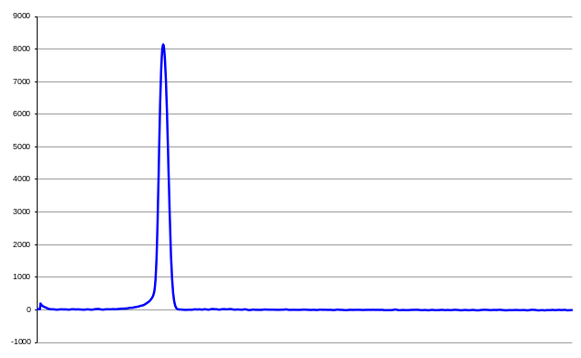
The spectra are represented internally as 1024 elements of 16 bit signed data (2048 bytes). To reduce bandwidth requirements, the spectra are compressed before transmission to 1024 elements of 4 bit nibbles (512 bytes) embedded as described below for an LCDA G Spectrum.

Byte | Field | Type | Value
0 | Sync Byte | Byte | 0x7E
1 | Sync Byte | Byte | 0x7E
2 | Message Type | Byte | 0x84
3-4 | Data Length | unsigned Short | 516
5-8 | time_t | Integer | The number of seconds since midnight of January 1, 1970.
9-520 | nibbles | packed unsigned Byte | Encoded 1024 element spectrum.
Len-1 | Checksum | Byte | Checksum

Spectrum Message Data Format

Sync | Sync | Type | Length | Length | time_t | nibble[0,1] | ... | nibble[1022,1023] | Chk
0x7E | 0x7E | 0x84 | 0x04 | 0x02 |  |  |  |  | 0xnn
0 | 1 | 2 | 3 | 4 | 5-8 | 9 |  | 520 | 521

Nibble[0] is encoded in the highest four bits of the first data byte. Nibble[1] is encoded in the lowest four bits of the first data byte.
Obtain the first nibble as ( (Data AND 0xF0) >> 4 ) and the second as ( Data AND 0x0F ). The nibbles are coded as sign-and-magnitude (not two's complement) and are expanded as described below.

ADPCM_Decode

Spectral Source Data
A typical 1024 element spectrum might be,
Input[] =
{
32, 32, 32, 32, 32, 32, 187, 166, 137, 113,
112, 100, 92, 87, 83, 77, 69, 62, 54, 49,
41, 37, 34, 31, 30, 28, 30, 28, 29, 28,
28, 27, 26, 24, 23, 22, 21, 22, 22, 24,
26, 26, 28, 28, 27, 26, 23, 21, 17, 16,
13, 12, 11, 13, 15, 18, 21, 23, 25, 26,
25, 26, 24, 24, 23, 23, 23, 24, 23, 23,
21, 19, 19, 20, 22, 23, 26, 27, 28, 27,
26, 25, 23, 21, 19, 18, 18, 18, 19, 19,
18, 18, 16, 16, 15, 14, 15, 16, 17, 20,
20, 22, 21, 20, 21, 21, 21, 23, 23, 24,
24, 23, 23, 21, 17, 15, 13, 13, 13, 14,
17, 17, 17, 17, 17, 15, 17, 17, 16, 16,
16, 15, 17, 19, 20, 22, 24, 26, 29, 31,
34, 34, 35, 36, 34, 32, 30, 28, 28, 29,
31, 31, 33, 37, 40, 41, 43, 43, 44, 43,
44, 45, 46, 48, 49, 52, 55, 57, 59, 60,
62, 62, 65, 67, 70, 75, 80, 85, 90, 97,
102, 104, 107, 110, 110, 110, 109, 107, 106, 103,
102, 100, 98, 99, 100, 103, 105, 111, 116, 122,
129, 135, 141, 146, 151, 158, 165, 174, 184, 194,
207, 220, 234, 248, 264, 279, 294, 310, 328, 348,
372, 401, 440, 494, 575, 697, 879, 1144, 1507, 1981,
2566, 3244, 3986, 4752, 5499, 6190, 6790, 7283, 7659, 7917,
8065, 8107, 8056, 7915, 7691, 7388, 7006, 6556, 6042, 5480,
4881, 4269, 3661, 3076, 2532, 2045, 1618, 1257, 960, 723,
538, 394, 286, 206, 148, 103, 72, 52, 39, 28,
23, 21, 17, 14, 14, 13, 12, 11, 10, 11,
10, 12, 13, 15, 16, 17, 18, 19, 21, 19,
16, 17, 16, 16, 15, 14, 14, 12, 10, 11,
10, 10, 10, 10, 8, 8, 7, 6, 7, 7,
8, 11, 15, 18, 22, 23, 26, 25, 24, 23,
22, 21, 21, 21, 22, 23, 25, 28, 28, 28,
28, 27, 25, 24, 23, 22, 23, 21, 21, 23,
22, 23, 22, 24, 23, 22, 21, 21, 21, 19,
15, 15, 15, 15, 15, 15, 14, 14, 13, 12,
10, 10, 12, 13, 13, 13, 13, 13, 12, 11,
11, 10, 11, 10, 12, 12, 12, 13, 15, 15,
16, 18, 19, 19, 19, 20, 19, 20, 20, 18,
17, 16, 14, 14, 15, 13, 13, 15, 15, 15,
15, 15, 15, 13, 11, 10, 8, 9, 12, 12,
13, 16, 19, 22, 23, 26, 26, 24, 22, 19,
15, 11, 8, 5, 3, 2, 3, 5, 6, 8,
7, 8, 7, 7, 6, 6, 6, 4, 2, 2,
2, 2, 2, 4, 6, 7, 8, 9, 11, 12,
11, 10, 9, 8, 7, 7, 9, 10, 13, 15,
19, 19, 19, 17, 16, 13, 10, 8, 7, 5,
4, 5, 6, 5, 6, 7, 8, 8, 8, 9,
10, 12, 11, 10, 12, 9, 10, 8, 8, 6,
7, 6, 7, 7, 6, 4, 4, 4, 4, 4,
6, 7, 10, 10, 10, 9, 8, 7, 6, 6,
4, 5, 3, 2, 2, 2, 4, 4, 7, 11,
13, 14, 15, 15, 14, 12, 10, 8, 8, 8,
8, 10, 9, 9, 9, 8, 8, 7, 8, 8,
8, 8, 8, 6, 5, 4, 4, 3, 4, 4,
4, 4, 5, 6, 7, 6, 6, 5, 6, 6,
7, 6, 8, 7, 7, 8, 8, 10, 11, 12,
12, 12, 12, 11, 10, 8, 6, 6, 5, 4,
6, 6, 7, 8, 8, 6, 6, 5, 4, 4,
2, 1, 0, -1, 0, 0, 1, 2, 5, 7,
8, 6, 6, 6, 7, 7, 10, 12, 13, 13,
13, 13, 10, 8, 6, 5, 2, 1, 0, -1,
0, 1, 3, 4, 4, 4, 4, 2, 1, 1,
1, 1, 2, 4, 6, 6, 8, 6, 6, 6,
6, 7, 8, 8, 8, 8, 6, 5, 3, 2,
2, -1, -1, -2, -2, -2, -4, -5, -4, -5,
-5, -4, -3, -3, -2, 0, -1, 1, 0, 1,
1, 1, 1, 2, 3, 1, 2, 1, -1, -1,
-3, -3, -1, 2, 2, 4, 6, 6, 4, 1,
1, 1, 1, 1, 2, 3, 2, 3, 2, 2,
2, 4, 4, 2, 1, -1, -1, -3, -3, -3,
-3, -1, 1, 2, 2, 3, 2, 2, 0, -1,
-1, 1, 1, 2, 1, 1, 0, -1, -3, -5,
-5, -4, -3, -1, 1, 3, 6, 4, 6, 5,
3, 2, 0, -1, -2, -1, 0, 1, 1, 0,
1, 1, 2, 4, 5, 6, 5, 4, 3, 2,
2, 0, 0, 1, 1, 1, 3, 3, 4, 4,
2, -1, -3, -8, -12, -14, -16, -20, -18, -18,
-16, -12, -8, -5, -3, -3, -3, -3, -3, -4,
-5, -5, -5, -4, -5, -5, -3, -4, -5, -3,
-2, -1, -1, -1, -2, -3, -3, -2, -2, -2,
-3, 0, 1, 1, 3, 4, 5, 6, 6, 5,
4, 2, 0, -3, -4, -6, -7, -8, -9, -7,
-7, -7, -3, -1, 0, 0, 0, -2, -4, -5,
-5, -6, -5, -4, -5, -5, -5, -6, -7, -7,
-5, -5, -4, -4, -3, -2, -3, -3, -3, -3,
-3, -2, -3, -2, -4, -5, -5, -5, -5, -3,
-3, -1, 1, 2, 4, 5, 6, 6, 5, 6,
6, 4, 2, -1, -3, -5, -6, -5, -6, -5,
-5, -4, -4, -4, -4, -3, -1, 0, 2, 2,
3, 2, 0, -4, -5, -7, -9, -7, -6, -4,
-3, -1, 0, 1, 1, 0, -1, -2, -3, -3,
-5, -4, -5, -5, -4, -3, -2, -1, -2, -2,
-3, -5, -8, -11, -13, -14, -16, -16, -14, -13,
-9, -5, -1, 1, 4, 7, 10, 9, 8, 6,
3, 1, -3, -5, -7, -7, -8, -7, -8, -7,
-6, -7, -8, -8, -9, -8, -7, -5, -5, -3,
-3, -3, -4, -3, -1, 1, 1, 1, 3, 3,
1, 1, 1, -2, -3, -4, -4, -5, -5, -5,
-4, -4, -4, -3, -2, -3, -3, -2, -1, -1,
1, 0, 0, -2, -3, -5, -6, -7, -8, -9,
-11, -11, -11, -9, -8, -6, -4, -1, 0, 1,
1, 1, 1, 0
}

This compresses using ADPCM to 1024 nibbles. Although these will normally be packed into the 512 message bytes they are reproduced here as an array to facilitate use for testing.

ADPCM Nibble Data

Output[] =
{
7, 5, 8, 0, 8, 0, 7, 7, 0, 9,
0, 9, 8, 8, 8, 8, 9, 8, 9, 8,
9, 9, 8, 9, 0, 9, 1, 9, 1, 9,
0, 8, 9, 9, 9, 9, 9, 0, 0, 1,
2, 0, 1, 1, 9, 9, 10, 9, 11, 9,
11, 9, 9, 1, 2, 2, 2, 1, 2, 1,
9, 1, 9, 9, 9, 0, 0, 1, 9, 0,
9, 10, 0, 1, 1, 1, 3, 1, 1, 9,
9, 9, 9, 10, 9, 9, 9, 0, 1, 0,
9, 0, 9, 9, 9, 9, 1, 1, 1, 2,
0, 1, 0, 9, 1, 0, 0, 1, 1, 1,
0, 9, 0, 9, 11, 10, 9, 9, 0, 1,
2, 0, 0, 0, 0, 9, 1, 0, 9, 0,
0, 9, 1, 2, 1, 1, 2, 1, 3, 1,
3, 0, 1, 1, 9, 10, 9, 10, 0, 1,
1, 1, 1, 3, 3, 1, 1, 1, 1, 9,
1, 1, 1, 1, 1, 3, 2, 1, 2, 1,
1, 1, 2, 1, 3, 3, 3, 4, 2, 3,
3, 2, 2, 2, 0, 0, 9, 9, 9, 11,
9, 9, 10, 1, 1, 2, 1, 4, 2, 3,
3, 5, 2, 2, 2, 3, 3, 7, 2, 3,
3, 5, 3, 3, 4, 3, 4, 3, 4, 3,
5, 4, 4, 5, 5, 5, 5, 5, 5, 4,
4, 4, 4, 3, 3, 3, 4, 2, 1, 1,
1, 0, 8, 9, 10, 11, 12, 12, 11, 13,
11, 12, 11, 11, 11, 11, 11, 10, 11, 10,
10, 9, 9, 9, 8, 9, 8, 8, 8, 0,
8, 8, 0, 8, 0, 8, 8, 0, 8, 0,
8, 0, 0, 8, 0, 0, 8, 0, 0, 8,
8, 0, 8, 8, 8, 8, 0, 9, 9, 1,
9, 9, 0, 0, 9, 9, 9, 9, 1, 0,
1, 2, 3, 2, 3, 1, 2, 9, 9, 9,
9, 9, 0, 0, 1, 1, 1, 3, 0, 0,
0, 9, 9, 9, 9, 9, 0, 9, 9, 1,
0, 1, 9, 1, 0, 9, 9, 0, 0, 9,
11, 9, 0, 0, 0, 0, 9, 0, 9, 9,
9, 9, 1, 1, 1, 0, 0, 0, 9, 9,
0, 9, 1, 9, 1, 1, 0, 1, 1, 1,
1, 1, 1, 1, 0, 1, 9, 1, 0, 9,
9, 9, 10, 0, 1, 9, 9, 1, 1, 0,
0, 0, 0, 9, 10, 9, 9, 0, 2, 0,
1, 2, 2, 2, 1, 2, 0, 9, 10, 10,
11, 11, 10, 10, 9, 9, 0, 1, 1, 2,
9, 1, 9, 0, 9, 0, 0, 9, 10, 0,
0, 0, 0, 1, 2, 1, 1, 1, 1, 1,
0, 9, 9, 9, 9, 0, 1, 1, 3, 1,
3, 1, 0, 9, 9, 11, 10, 9, 9, 10,
9, 1, 1, 9, 1, 1, 1, 0, 0, 1,
1, 1, 0, 9, 1, 9, 0, 9, 9, 9,
0, 9, 1, 0, 9, 9, 9, 0, 0, 0,
1, 1, 3, 0, 0, 9, 9, 9, 9, 0,
9, 0, 9, 9, 9, 0, 1, 1, 2, 3,
1, 1, 1, 1, 9, 9, 10, 9, 9, 0,
0, 1, 0, 0, 0, 9, 0, 9, 1, 0,
0, 0, 0, 9, 9, 9, 9, 9, 1, 0,
0, 0, 1, 1, 1, 9, 0, 9, 1, 0,
1, 9, 1, 0, 0, 1, 0, 1, 1, 1,
1, 0, 0, 9, 9, 9, 10, 0, 9, 9,
1, 1, 1, 1, 0, 9, 9, 9, 9, 0,
9, 9, 9, 9, 0, 0, 1, 1, 2, 1,
1, 9, 0, 0, 1, 0, 2, 1, 1, 1,
0, 0, 10, 9, 10, 9, 10, 9, 9, 9,
1, 1, 1, 1, 1, 0, 0, 9, 9, 9,
0, 0, 1, 1, 2, 0, 1, 9, 0, 0,
0, 1, 1, 0, 0, 0, 9, 9, 10, 9,
0, 10, 0, 9, 0, 0, 9, 9, 0, 9,
0, 1, 1, 0, 1, 1, 0, 1, 0, 1,
0, 0, 0, 1, 1, 9, 0, 9, 9, 9,
9, 9, 1, 3, 0, 1, 2, 0, 9, 11,
0, 0, 0, 0, 1, 1, 9, 1, 9, 0,
0, 1, 1, 9, 9, 10, 0, 9, 9, 0,
0, 1, 2, 1, 0, 1, 9, 0, 9, 9,
9, 1, 1, 1, 9, 0, 9, 9, 9, 10,
0, 1, 1, 1, 2, 1, 3, 9, 1, 9,
9, 9, 10, 9, 9, 1, 1, 1, 0, 9,
1, 0, 1, 1, 1, 1, 0, 9, 9, 9,
0, 9, 9, 1, 0, 0, 1, 1, 1, 0,
9, 11, 9, 11, 11, 11, 9, 11, 1, 0,
1, 3, 3, 3, 1, 1, 0, 0, 0, 9,
9, 0, 0, 1, 9, 0, 1, 0, 9, 1,
1, 1, 1, 0, 9, 9, 0, 1, 0, 0,
9, 2, 1, 0, 1, 1, 1, 1, 1, 9,
9, 9, 10, 10, 9, 9, 9, 9, 9, 1,
0, 0, 3, 1, 1, 1, 0, 9, 10, 9,
0, 9, 1, 1, 9, 0, 0, 9, 9, 0,
1, 1, 1, 0, 1, 1, 9, 0, 0, 0,
0, 1, 9, 1, 9, 9, 9, 0, 0, 1,
1, 1, 2, 1, 1, 1, 1, 1, 9, 1,
0, 9, 10, 10, 9, 10, 9, 1, 9, 1,
0, 1, 0, 0, 0, 1, 1, 1, 2, 0,
1, 9, 9, 11, 9, 10, 9, 1, 1, 1,
1, 2, 1, 1, 0, 9, 9, 9, 9, 0,
9, 0, 9, 0, 1, 1, 1, 1, 9, 0,
9, 9, 11, 10, 9, 9, 10, 0, 1, 1,
3, 3, 3, 2, 2, 2, 2, 9, 9, 9,
11, 9, 11, 10, 9, 9, 9, 1, 9, 1,
1, 9, 9, 0, 9, 1, 1, 1, 1, 1,
1, 0, 9, 1, 1, 2, 0, 0, 1, 1,
9, 9, 0, 10, 9, 9, 0, 9, 0, 0,
1, 0, 0, 1, 1, 9, 0, 1, 1, 0,
1, 0, 0, 9, 9, 10, 9, 9, 9, 9,
9, 9, 0, 1, 1, 2, 1, 3, 1, 1,
0, 0, 0, 9
}

When decompressed the reconstructed data closely resemble the original. The compressed data are reproduced below packed into bytes.

ADPCM Byte Data

TestSpectrum[] =
{
0x75, 0x80, 0x80, 0x77, 0x09, 0x09, 0x88, 0x88,
0x98, 0x98, 0x99, 0x89, 0x09, 0x19, 0x19, 0x08,
0x99, 0x99, 0x90, 0x01, 0x20, 0x11, 0x99, 0xa9,
0xb9, 0xb9, 0x91, 0x22, 0x21, 0x21, 0x91, 0x99,
0x90, 0x01, 0x90, 0x9a, 0x01, 0x11, 0x31, 0x19,
0x99, 0x9a, 0x99, 0x90, 0x10, 0x90, 0x99, 0x99,
0x11, 0x12, 0x01, 0x09, 0x10, 0x01, 0x11, 0x09,
0x09, 0xba, 0x99, 0x01, 0x20, 0x00, 0x09, 0x10,
0x90, 0x09, 0x12, 0x11, 0x21, 0x31, 0x30, 0x11,
0x9a, 0x9a, 0x01, 0x11, 0x13, 0x31, 0x11, 0x19,
0x11, 0x11, 0x13, 0x21, 0x21, 0x11, 0x21, 0x33,
0x34, 0x23, 0x32, 0x22, 0x00, 0x99, 0x9b, 0x99,
0xa1, 0x12, 0x14, 0x23, 0x35, 0x22, 0x23, 0x37,
0x23, 0x35, 0x33, 0x43, 0x43, 0x43, 0x54, 0x45,
0x55, 0x55, 0x54, 0x44, 0x43, 0x33, 0x42, 0x11,
0x10, 0x89, 0xab, 0xcc, 0xbd, 0xbc, 0xbb, 0xbb,
0xba, 0xba, 0xa9, 0x99, 0x89, 0x88, 0x80, 0x88,
0x08, 0x08, 0x80, 0x80, 0x80, 0x08, 0x00, 0x80,
0x08, 0x80, 0x88, 0x88, 0x09, 0x91, 0x99, 0x00,
0x99, 0x99, 0x10, 0x12, 0x32, 0x31, 0x29, 0x99,
0x99, 0x00, 0x11, 0x13, 0x00, 0x09, 0x99, 0x99,
0x09, 0x91, 0x01, 0x91, 0x09, 0x90, 0x09, 0xb9,
0x00, 0x00, 0x90, 0x99, 0x99, 0x11, 0x10, 0x00,
0x99, 0x09, 0x19, 0x11, 0x01, 0x11, 0x11, 0x11,
0x01, 0x91, 0x09, 0x99, 0xa0, 0x19, 0x91, 0x10,
0x00, 0x09, 0xa9, 0x90, 0x20, 0x12, 0x22, 0x12,
0x09, 0xaa, 0xbb, 0xaa, 0x99, 0x01, 0x12, 0x91,
0x90, 0x90, 0x09, 0xa0, 0x00, 0x01, 0x21, 0x11,
0x11, 0x09, 0x99, 0x90, 0x11, 0x31, 0x31, 0x09,
0x9b, 0xa9, 0x9a, 0x91, 0x19, 0x11, 0x10, 0x01,
0x11, 0x09, 0x19, 0x09, 0x99, 0x09, 0x10, 0x99,
0x90, 0x00, 0x11, 0x30, 0x09, 0x99, 0x90, 0x90,
0x99, 0x90, 0x11, 0x23, 0x11, 0x11, 0x99, 0xa9,
0x90, 0x01, 0x00, 0x09, 0x09, 0x10, 0x00, 0x09,
0x99, 0x99, 0x10, 0x00, 0x11, 0x19, 0x09, 0x10,
0x19, 0x10, 0x01, 0x01, 0x11, 0x10, 0x09, 0x99,
0xa0, 0x99, 0x11, 0x11, 0x09, 0x99, 0x90, 0x99,
0x99, 0x00, 0x11, 0x21, 0x19, 0x00, 0x10, 0x21,
0x11, 0x00, 0xa9, 0xa9, 0xa9, 0x99, 0x11, 0x11,
0x10, 0x09, 0x99, 0x00, 0x11, 0x20, 0x19, 0x00,
0x01, 0x10, 0x00, 0x99, 0xa9, 0x0a, 0x09, 0x00,
0x99, 0x09, 0x01, 0x10, 0x11, 0x01, 0x01, 0x00,
0x01, 0x19, 0x09, 0x99, 0x99, 0x13, 0x01, 0x20,
0x9b, 0x00, 0x00, 0x11, 0x91, 0x90, 0x01, 0x19,
0x9a, 0x09, 0x90, 0x01, 0x21, 0x01, 0x90, 0x99,
0x91, 0x11, 0x90, 0x99, 0x9a, 0x01, 0x11, 0x21,
0x39, 0x19, 0x99, 0xa9, 0x91, 0x11, 0x09, 0x10,
0x11, 0x11, 0x09, 0x99, 0x09, 0x91, 0x00, 0x11,
0x10, 0x9b, 0x9b, 0xbb, 0x9b, 0x10, 0x13, 0x33,
0x11, 0x00, 0x09, 0x90, 0x01, 0x90, 0x10, 0x91,
0x11, 0x10, 0x99, 0x01, 0x00, 0x92, 0x10, 0x11,
0x11, 0x19, 0x99, 0xaa, 0x99, 0x99, 0x91, 0x00,
0x31, 0x11, 0x09, 0xa9, 0x09, 0x11, 0x90, 0x09,
0x90, 0x11, 0x10, 0x11, 0x90, 0x00, 0x01, 0x91,
0x99, 0x90, 0x01, 0x11, 0x21, 0x11, 0x11, 0x91,
0x09, 0xaa, 0x9a, 0x91, 0x91, 0x01, 0x00, 0x01,
0x11, 0x20, 0x19, 0x9b, 0x9a, 0x91, 0x11, 0x12,
0x11, 0x09, 0x99, 0x90, 0x90, 0x90, 0x11, 0x11,
0x90, 0x99, 0xba, 0x99, 0xa0, 0x11, 0x33, 0x32,
0x22, 0x29, 0x99, 0xb9, 0xba, 0x99, 0x91, 0x91,
0x19, 0x90, 0x91, 0x11, 0x11, 0x10, 0x91, 0x12,
0x00, 0x11, 0x99, 0x0a, 0x99, 0x09, 0x00, 0x10,
0x01, 0x19, 0x01, 0x10, 0x10, 0x09, 0x9a, 0x99,
0x99, 0x99, 0x01, 0x12, 0x13, 0x11, 0x00, 0x09
}

Reconstructed Data

Reconstruction[] =
{
11, 33, 31, 33, 31, 33, 63, 126, 135, 111,
118, 99, 93, 88, 83, 79, 67, 64, 54, 51,
44, 37, 35, 29, 31, 27, 31, 27, 30, 27,
28, 27, 26, 25, 24, 23, 22, 22, 22, 23,
26, 26, 27, 28, 27, 26, 23, 22, 18, 17,
13, 12, 11, 12, 15, 18, 21, 22, 25, 26,
25, 26, 25, 24, 23, 23, 23, 24, 23, 23,
22, 19, 19, 20, 21, 22, 26, 27, 28, 27,
26, 25, 24, 21, 20, 19, 18, 18, 19, 19,
18, 18, 17, 16, 15, 14, 15, 16, 17, 20,
20, 21, 21, 20, 21, 21, 21, 22, 23, 24,
24, 23, 23, 22, 18, 15, 14, 13, 13, 14,
17, 17, 17, 17, 17, 16, 17, 17, 16, 16,
16, 15, 16, 19, 20, 21, 24, 25, 29, 30,
34, 34, 35, 36, 35, 32, 31, 28, 28, 29,
30, 31, 32, 36, 40, 41, 42, 43, 44, 43,
44, 45, 46, 47, 48, 52, 55, 56, 59, 60,
61, 62, 65, 66, 70, 74, 78, 85, 90, 97,
101, 104, 107, 110, 110, 110, 109, 108, 107, 103,
102, 101, 98, 99, 100, 103, 104, 111, 116, 123,
127, 135, 141, 147, 152, 159, 163, 174, 184, 195,
205, 221, 235, 249, 264, 278, 296, 311, 330, 347,
372, 403, 441, 497, 579, 700, 878, 1138, 1520, 1979,
2534, 3206, 4020, 4786, 5482, 6115, 6855, 7352, 7623, 7869,
8092, 8160, 8099, 7931, 7676, 7353, 6974, 6515, 6084, 5467,
4892, 4220, 3587, 3012, 2490, 2014, 1583, 1303, 946, 715,
505, 391, 288, 194, 166, 88, 65, 44, 25, 42,
26, 12, 25, 13, 24, 14, 5, 13, 6, 12,
6, 11, 16, 12, 16, 19, 16, 19, 21, 19,
17, 19, 17, 16, 15, 14, 15, 12, 9, 12,
11, 10, 10, 10, 9, 8, 7, 6, 7, 7,
8, 11, 15, 18, 22, 23, 26, 25, 24, 23,
22, 21, 21, 21, 22, 23, 24, 28, 28, 28,
28, 27, 26, 25, 24, 23, 23, 22, 21, 22,
22, 23, 22, 23, 23, 22, 21, 21, 21, 20,
16, 15, 15, 15, 15, 15, 14, 14, 13, 12,
11, 10, 11, 12, 13, 13, 13, 13, 12, 11,
11, 10, 11, 10, 11, 12, 12, 13, 14, 15,
16, 17, 18, 19, 19, 20, 19, 20, 20, 19,
18, 17, 14, 14, 15, 14, 13, 14, 15, 15,
15, 15, 15, 14, 11, 10, 9, 9, 12, 12,
13, 16, 19, 22, 23, 26, 26, 25, 22, 19,
15, 11, 8, 5, 4, 3, 3, 4, 5, 8,
7, 8, 7, 7, 6, 6, 6, 5, 2, 2,
2, 2, 2, 3, 6, 7, 8, 9, 10, 11,
11, 10, 9, 8, 7, 7, 8, 9, 13, 14,
18, 19, 19, 18, 17, 13, 10, 9, 8, 5,
4, 5, 6, 5, 6, 7, 8, 8, 8, 9,
10, 11, 11, 10, 11, 10, 10, 9, 8, 7,
7, 6, 7, 7, 6, 5, 4, 4, 4, 4,
5, 6, 10, 10, 10, 9, 8, 7, 6, 6,
5, 5, 4, 3, 2, 2, 3, 4, 7, 11,
12, 13, 14, 15, 14, 13, 10, 9, 8, 8,
8, 9, 9, 9, 9, 8, 8, 7, 8, 8,
8, 8, 8, 7, 6, 5, 4, 3, 4, 4,
4, 4, 5, 6, 7, 6, 6, 5, 6, 6,
7, 6, 7, 7, 7, 8, 8, 9, 10, 11,
12, 12, 12, 11, 10, 9, 6, 6, 5, 4,
5, 6, 7, 8, 8, 7, 6, 5, 4, 4,
3, 2, 1, 0, 0, 0, 1, 2, 5, 6,
7, 6, 6, 6, 7, 7, 10, 11, 12, 13,
13, 13, 10, 9, 6, 5, 2, 1, 0, -1,
0, 1, 2, 3, 4, 4, 4, 3, 2, 1,
1, 1, 2, 3, 6, 6, 7, 6, 6, 6,
6, 7, 8, 8, 8, 8, 7, 6, 3, 2,
2, -1, -1, -2, -2, -2, -3, -4, -4, -5,
-5, -4, -3, -3, -2, -1, -1, 0, 0, 1,
1, 1, 1, 2, 3, 2, 2, 1, 0, -1,
-2, -3, -2, 2, 2, 3, 6, 6, 5, 1,
1, 1, 1, 1, 2, 3, 2, 3, 2, 2,
2, 3, 4, 3, 2, -1, -1, -2, -3, -3,
-3, -2, 1, 2, 2, 3, 2, 2, 1, 0,
-1, 0, 1, 2, 1, 1, 0, -1, -2, -5,
-5, -4, -3, -2, 1, 2, 6, 5, 6, 5,
4, 3, 0, -1, -2, -1, 0, 1, 1, 0,
1, 1, 2, 3, 4, 5, 5, 4, 3, 2,
2, 1, 0, 1, 1, 1, 2, 3, 4, 4,
3, -1, -2, -6, -10, -14, -15, -19, -18, -18,
-17, -13, -9, -5, -4, -3, -3, -3, -3, -4,
-5, -5, -5, -4, -5, -5, -4, -4, -5, -4,
-3, -2, -1, -1, -2, -3, -3, -2, -2, -2,
-3, 0, 1, 1, 2, 3, 4, 5, 6, 5,
4, 3, 0, -3, -4, -5, -6, -7, -8, -7,
-7, -7, -3, -2, -1, 0, 0, -1, -4, -5,
-5, -6, -5, -4, -5, -5, -5, -6, -7, -7,
-6, -5, -4, -4, -3, -2, -3, -3, -3, -3,
-3, -2, -3, -2, -3, -4, -5, -5, -5, -4,
-3, -2, 1, 2, 3, 4, 5, 6, 5, 6,
6, 5, 2, -1, -2, -5, -6, -5, -6, -5,
-5, -4, -4, -4, -4, -3, -2, -1, 2, 2,
3, 2, 1, -3, -4, -7, -8, -7, -6, -5,
-4, -1, 0, 1, 1, 0, -1, -2, -3, -3,
-4, -4, -5, -5, -4, -3, -2, -1, -2, -2,
-3, -4, -8, -11, -12, -13, -16, -16, -15, -14,
-10, -6, -2, 1, 4, 7, 10, 9, 8, 7,
3, 2, -2, -5, -6, -7, -8, -7, -8, -7,
-6, -7, -8, -8, -9, -8, -7, -6, -5, -4,
-3, -3, -4, -3, -2, 1, 1, 1, 2, 3,
2, 1, 1, -2, -3, -4, -4, -5, -5, -5,
-4, -4, -4, -3, -2, -3, -3, -2, -1, -1,
0, 0, 0, -1, -2, -5, -6, -7, -8, -9,
-10, -11, -11, -10, -9, -6, -5, -1, 0, 1,
1, 1, 1, 0
}

Original and Reconstruction graphed

The original and reconstructed spectra are reproduced below.

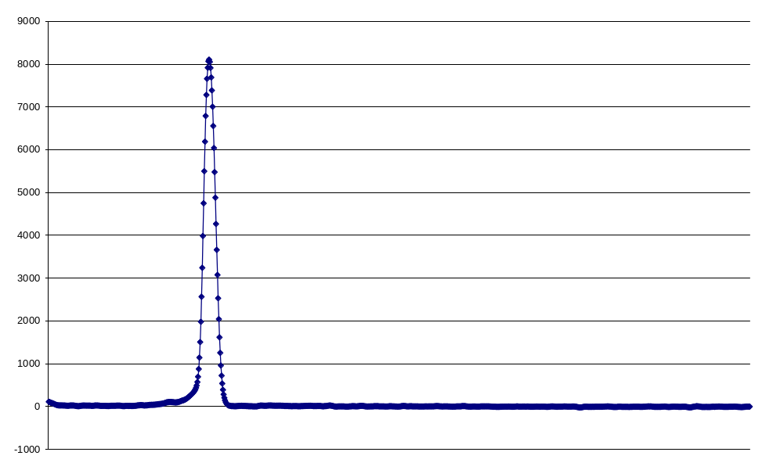
Original Data

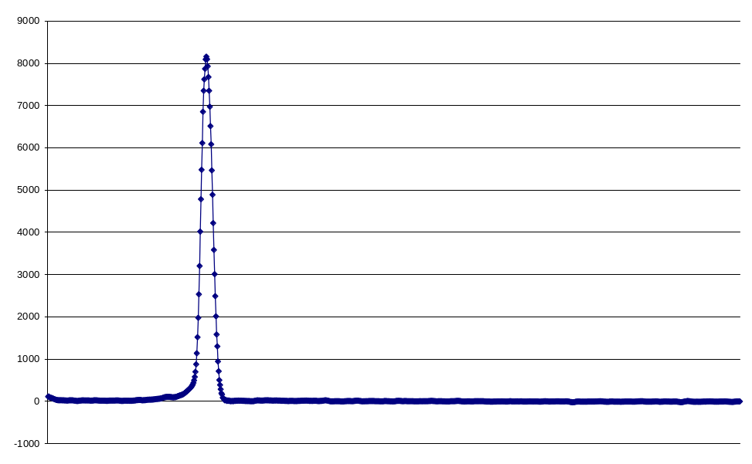
Reconstructed Data

Although the compression is slightly lossy, ADPCM was chosen for its high data compression rate, deterministic output (25% of original data size) and suitability to the spectral data type.

A "generic" C language ADPCM_Decode function is reproduced below and can be used as the basis for realization in other programming languages. The "Output" and " Reconstruction" arrays above can be used for testing. For the processing of actual "Spectrum" messages, the data nibbles must first be extracted from the message data payload before being passed to the ADPCM_Decode Function.

ADPCM_Decode Function

#define N_STEP_VALUES 89

const int StepTable[N_STEP_VALUES] =
{
7,8,9,10,11,12,13,14,16,17,
19,21,23,25,28,31,34,37,41,45,
50,55,60,66,73,80,88,97,107,118,
130,143,157,173,190,209,230,253,279,307,
337,371,408,449,494,544,598,658,724,796,
876,963,1060,1166,1282,1411,1552,1707,1878,2066,
2272,2499,2749,3024,3327,3660,4026,4428,4871,5358,
5894,6484,7132,7845,8630,9493,10442,11487,12635,13899,
15289,16818,18500,20350,22385,24623,27086,29794,32767
};

const int IndexAdjustTable[16] = {-1,-1,-1,-1,2,4,6,8,-1,-1,-1,-1,2,4,6,8};

short ADPCM_Decode(unsigned char Nibble)
{
static int Index = 0; //takes values 0..15
static int Reconstruction = 0; //must be 32 bit to avoid 16 bit overflow
int StepValue = 0; //takes values 7..32767
int Delta = 0; //must be 32 bit to avoid 16 bit overflow

//load step value based on current index
StepValue = StepTable[Index];

//initialise delta as half nibble bit weight
Delta = StepValue >> 3;

//conditionally add step weight
if (Nibble & 4)
{
Delta = Delta + StepValue;
}

if (Nibble & 2)
{
Delta = Delta + (StepValue >> 1);
}

if (Nibble & 1)
{
Delta = Delta + (StepValue >> 2);
}

//test sign bit and subtract or add delta value
if (Nibble & 8)
{
Reconstruction = Reconstruction - Delta;
}
else
{
Reconstruction = Reconstruction + Delta;
}

//test to avoid signed 16 bit overflow
if (Reconstruction > 32767)
{
Reconstruction = 32767;
}
else if (Reconstruction < -32768)
{
Reconstruction = -32768;
}

//load a new quantizer StepValue size based on current nibble
Index = Index + IndexAdjustTable[Nibble];

//test to avoid under or overflowing table
if (Index < 0)
{
Index = 0;
}
if (Index > (N_STEP_VALUES - 1))
{
Index = (N_STEP_VALUES - 1);
}

//return an expanded signed 16 bit result
return ((short) Reconstruction);
}

LCDA G Spectrum
Format as described above ( Spectrum Message Data Format ) except the Type is 0x84.

LCDA H Spectrum
Format as described above ( Spectrum Message Data Format ) except the Type is 0x85.

LCDB G Spectrum
Format as described above ( Spectrum Message Data Format ) except the Type is 0x86.

LCDB H Spectrum
Format as described above ( Spectrum Message Data Format ) except the Type is 0x87.

Data Saved by ANACONDA

Data Logging
Data are saved in certain operating modes as described above in ModeIdle etc.
Data are saved to an SD card mounted on the Detector's Display PCB. LCD A and LCD B independently save data and any failure of one should not prejudice the other.
A FAT file system is used. The SD cards will typically be formatted FAT 16.
Five files are maintained. Each has an extension of "abn" (Anaconda Binary). This extension chosen as it is generally not found elsewhere.
SEARCH_1.abn
SEARCH_2.abn
SEARCH_3.abn
SEARCH_4.abn
ANACONDA.abn
New data are always appended to existing data. To start a new "clean" recording, delete the existing file. It will be recreated when necessary and new data written from the start.

File Description
The file contains records where each has a fixed length of (9 x 512) 4,608 bytes. There are two spectra each saved as 1024 x 16 bit = 4,096 bytes. The remaining 512 bytes are used for miscellaneous data. Unused bytes will always be zero. A start of record pattern should allow re-synchronization if data are missing or corrupt.

File Record Format
Data are stored little endian - least significant byte first

Version 3
Display software rev G writes version 3 records. These are completely backwards compatible with version 1 and version 2 records but include additional data when used with a System PCB running rev E software.
The original version 1 and 2 data are grayed out in the table below. Only GPSTime was added in version 3.

Offset | Type | Data Description
0 | Byte Array | four sync (0x7e) characters "~~~~"
4 | Byte | binary numeric value 1..255 identifies record version
5 | Byte | 'A' or 'B' identifies source of data LCD A or LCD B
6 | Byte | LCD Mode (eg MODE_IDLE 0x14) or one of 0x15, 0x16, 0x17, 0x18, 0x19, 0x1a, 0x1b
7 | Byte | LCD Previous Mode one of 0x14, 0x15, 0x16, 0x17, 0x18, 0x19, 0x1a, 0x1b
8 | time_t | Time
12 | uint32 | microcontroller internal unique identifier [0]
16 | uint32 | microcontroller internal unique identifier [1]
20 | uint32 | microcontroller internal unique identifier [2]
24 | Integer | GPS Longitude
28 | Integer | GPS Latitude
32 | Short | GPS Altitude
34 | float | Pressure (mBars)
38 | float | Temperature (K)
42 | float | Mobility of an imaginary peak at 1 millisecond in the G spectrum *
46 | float | Mobility of an imaginary peak at 1 millisecond in the H spectrum *
50 | Byte Array | Hazard Bar Levels for Agents 0..39 (see Agent Identity for more information)
... |  | <unused space>
300 | uint16 | ServoOpenPulseWidth (microseconds) (see SetServoOpenLimit)
302 | uint16 | ServoClosedPulseWidth (microseconds) (see SetServoClosedLimit)
304 | int16 | ManifoldHeaterSetPoint (The temperature is represented as a signed Short value to the nearest whole degree centigrade.)
306 | int16 | ManifoldHeaterActual (The temperature is represented as a signed Short value to the nearest whole degree centigrade.)
308 | int16 | PitotHeaterSetPoint (The temperature is represented as a signed Short value to the nearest whole degree centigrade.)
310 | int16 | PitotHeaterActual (The temperature is represented as a signed Short value to the nearest whole degree centigrade.)
312 | uint16 | VoltsReading (see Power)
314 | uint16 | AmpsReading (see Power)
316 | uint32 | SysBits (see System)
320 | time_t | GPSTime
... |  | <unused space starts at 324>
400 | Byte Array | Build String (eg "ANACONDA Display software Rev E built on Aug 5 2010 at 09:25:11.")  Zero terminated ASCII string
512 | Short Array | G Spectrum. 1024 signed 16 bit values
2,560 | Short Array | H Spectrum. 1024 signed 16 bit values

* The mobility of an imaginary peak at 1 millisecond in the G / H spectrum can be used with the spectra to calculate mobility for any bin. For any spectral bin in the range 0..1023 (note zero based index!), you can work out the mobility. Bins are spaced 20us apart. For example K0 of bin 461 - where 1ms value is 10.8334 - is 10.8334 / (461 * .02) = 1.175. The 1 millisecond mobility number may change from spectrum to spectrum and will be different between G and H modes. The amplitudes of bin values will be baselined near zero but may be positive or negative numbers.

Version 2
Display software rev F writes version 2 records. These are completely backwards compatible with version 1 records but include additional data when used with a System PCB running rev D software.
The original version 1 data are grayed out in the table below.

Offset | Type | Data Description
0 | Byte Array | four sync (0x7e) characters "~~~~"
4 | Byte | binary numeric value 1..255 identifies record version
5 | Byte | 'A' or 'B' identifies source of data LCD A or LCD B
6 | Byte | LCD Mode (eg MODE_IDLE 0x14) or one of 0x15, 0x16, 0x17, 0x18, 0x19, 0x1a, 0x1b
7 | Byte | LCD Previous Mode one of 0x14, 0x15, 0x16, 0x17, 0x18, 0x19, 0x1a, 0x1b
8 | time_t | Time
12 | uint32 | microcontroller internal unique identifier [0]
16 | uint32 | microcontroller internal unique identifier [1]
20 | uint32 | microcontroller internal unique identifier [2]
24 | Integer | GPS Longitude
28 | Integer | GPS Latitude
32 | Short | GPS Altitude
34 | float | Pressure (mBars)
38 | float | Temperature (K)
42 | float | Mobility of an imaginary peak at 1 millisecond in the G spectrum *
46 | float | Mobility of an imaginary peak at 1 millisecond in the H spectrum *
50 | Byte Array | Hazard Bar Levels for Agents 0..39 (see Agent Identity for more information)
... |  | <unused space>
300 | uint16 | ServoOpenPulseWidth (microseconds) (see SetServoOpenLimit)
302 | uint16 | ServoClosedPulseWidth (microseconds) (see SetServoClosedLimit)
304 | int16 | ManifoldHeaterSetPoint (The temperature is represented as a signed Short value to the nearest whole degree centigrade.)
306 | int16 | ManifoldHeaterActual (The temperature is represented as a signed Short value to the nearest whole degree centigrade.)
308 | int16 | PitotHeaterSetPoint (The temperature is represented as a signed Short value to the nearest whole degree centigrade.)
310 | int16 | PitotHeaterActual (The temperature is represented as a signed Short value to the nearest whole degree centigrade.)
312 | uint16 | VoltsReading (see Power)
314 | uint16 | AmpsReading (see Power)
316 | uint32 | SysBits (see System)
... |  | <unused space starts at 320>
400 | Byte Array | Build String (eg "ANACONDA Display software Rev E built on Aug 5 2010 at 09:25:11.")  Zero terminated ASCII string
512 | Short Array | G Spectrum. 1024 signed 16 bit values
2,560 | Short Array | H Spectrum. 1024 signed 16 bit values

* The mobility of an imaginary peak at 1 millisecond in the G / H spectrum can be used with the spectra to calculate mobility for any bin. For any spectral bin in the range 0..1023 (note zero based index!), you can work out the mobility. Bins are spaced 20us apart. For example K0 of bin 461 - where 1ms value is 10.8334 - is 10.8334 / (461 * .02) = 1.175. The 1 millisecond mobility number may change from spectrum to spectrum and will be different between G and H modes. The amplitudes of bin values will be baselined near zero but may be positive or negative numbers.

Version 1

Offset | Type | Data Description
0 | Byte Array | four sync (0x7e) characters "~~~~"
4 | Byte | binary numeric value 1..255 identifies record version
5 | Byte | 'A' or 'B' identifies source of data LCD A or LCD B
6 | Byte | LCD Mode (eg MODE_IDLE 0x14) or one of 0x15, 0x16, 0x17, 0x18, 0x19, 0x1a, 0x1b
7 | Byte | LCD Previous Mode one of 0x14, 0x15, 0x16, 0x17, 0x18, 0x19, 0x1a, 0x1b
8 | time_t | Time
12 | uint32 | microcontroller internal unique identifier [0]
16 | uint32 | microcontroller internal unique identifier [1]
20 | uint32 | microcontroller internal unique identifier [2]
24 | Integer | GPS Longitude
28 | Integer | GPS Latitude
32 | Short | GPS Altitude
34 | float | Pressure (mBars)
38 | float | Temperature (K)
42 | float | Mobility of an imaginary peak at 1 millisecond in the G spectrum *
46 | float | Mobility of an imaginary peak at 1 millisecond in the H spectrum *
50 | Byte Array | Hazard Bar Levels for Agents 0..39 (see Agent Identity for more information)
... |  | <unused space>
400 | Byte Array | Build String (eg "ANACONDA Display software Rev E built on Aug 5 2010 at 09:25:11.")  Zero terminated ASCII string
512 | Short Array | G Spectrum. 1024 signed 16 bit values
2,560 | Short Array | H Spectrum. 1024 signed 16 bit values

* The mobility of an imaginary peak at 1 millisecond in the G / H spectrum can be used with the spectra to calculate mobility for any bin. For any spectral bin in the range 0..1023 (note zero based index!), you can work out the mobility. Bins are spaced 20us apart. For example K0 of bin 461 - where 1ms value is 10.8334 - is 10.8334 / (461 * .02) = 1.175. The 1 millisecond mobility number may change from spectrum to spectrum and will be different between G and H modes. The amplitudes of bin values will be baselined near zero but may be positive or negative numbers.

Centigrade to Fahrenheit Table

-40 | -40 | -20 | -4 | 0 | 32 | 20 | 68 | 40 | 104 | 60 | 140 | 80 | 176 | 100 | 212 | 120 | 248
-39 | -38.2 | -19 | -2.2 | 1 | 33.8 | 21 | 69.8 | 41 | 105.8 | 61 | 141.8 | 81 | 177.8 | 101 | 213.8 | 121 | 249.8
-38 | -36.4 | -18 | -0.4 | 2 | 35.6 | 22 | 71.6 | 42 | 107.6 | 62 | 143.6 | 82 | 179.6 | 102 | 215.6 | 122 | 251.6
-37 | -34.6 | -17 | 1.4 | 3 | 37.4 | 23 | 73.4 | 43 | 109.4 | 63 | 145.4 | 83 | 181.4 | 103 | 217.4 | 123 | 253.4
-36 | -32.8 | -16 | 3.2 | 4 | 39.2 | 24 | 75.2 | 44 | 111.2 | 64 | 147.2 | 84 | 183.2 | 104 | 219.2 | 124 | 255.2
-35 | -31 | -15 | 5 | 5 | 41 | 25 | 77 | 45 | 113 | 65 | 149 | 85 | 185 | 105 | 221 | 125 | 257
-34 | -29.2 | -14 | 6.8 | 6 | 42.8 | 26 | 78.8 | 46 | 114.8 | 66 | 150.8 | 86 | 186.8 | 106 | 222.8
-33 | -27.4 | -13 | 8.6 | 7 | 44.6 | 27 | 80.6 | 47 | 116.6 | 67 | 152.6 | 87 | 188.6 | 107 | 224.6
-32 | -25.6 | -12 | 10.4 | 8 | 46.4 | 28 | 82.4 | 48 | 118.4 | 68 | 154.4 | 88 | 190.4 | 108 | 226.4
-31 | -23.8 | -11 | 12.2 | 9 | 48.2 | 29 | 84.2 | 49 | 120.2 | 69 | 156.2 | 89 | 192.2 | 109 | 228.2
-30 | -22 | -10 | 14 | 10 | 50 | 30 | 86 | 50 | 122 | 70 | 158 | 90 | 194 | 110 | 230
-29 | -20.2 | -9 | 15.8 | 11 | 51.8 | 31 | 87.8 | 51 | 123.8 | 71 | 159.8 | 91 | 195.8 | 111 | 231.8
-28 | -18.4 | -8 | 17.6 | 12 | 53.6 | 32 | 89.6 | 52 | 125.6 | 72 | 161.6 | 92 | 197.6 | 112 | 233.6
-27 | -16.6 | -7 | 19.4 | 13 | 55.4 | 33 | 91.4 | 53 | 127.4 | 73 | 163.4 | 93 | 199.4 | 113 | 235.4
-26 | -14.8 | -6 | 21.2 | 14 | 57.2 | 34 | 93.2 | 54 | 129.2 | 74 | 165.2 | 94 | 201.2 | 114 | 237.2
-25 | -13 | -5 | 23 | 15 | 59 | 35 | 95 | 55 | 131 | 75 | 167 | 95 | 203 | 115 | 239
-24 | -11.2 | -4 | 24.8 | 16 | 60.8 | 36 | 96.8 | 56 | 132.8 | 76 | 168.8 | 96 | 204.8 | 116 | 240.8
-23 | -9.4 | -3 | 26.6 | 17 | 62.6 | 37 | 98.6 | 57 | 134.6 | 77 | 170.6 | 97 | 206.6 | 117 | 242.6
-22 | -7.6 | -2 | 28.4 | 18 | 64.4 | 38 | 100.4 | 58 | 136.4 | 78 | 172.4 | 98 | 208.4 | 118 | 244.4
-21 | -5.8 | -1 | 30.2 | 19 | 66.2 | 39 | 102.2 | 59 | 138.2 | 79 | 174.2 | 99 | 210.2 | 119 | 246.2

Agent Identity

Example AgentID codes

1 | GA
2 | GB
3 | GD
4 | GF
5 | VX
6 | DPM
7 | VXr
8 | DMMP
9 | TEP
...
12 | CK
13 | HCN
14 | HD
15 | HN
16 | L
17 | MS
...
27 | DPM
...
31 | CG
32 | HS
33 | HF
34 | Cl
35 | HCl
36 | HBr
37 | MS

Operating Cycle

The detectors will be configured to perform a detection event every half second. Although ideally the detectors would be configured to cycle alternately, the single serial reporting channel imposes some restrictions. More complex operation may ultimately be achieved however the following is a guide to basic operation.

Messages are sent and received via the System PCB which is internally linked to the LCDA and LCDB detectors. If one or both of the detectors fails to communicate with the System PCB then the Status Message will be sent once every cycle. The cycle period is based on the time required for sample detection and will typically be about 500ms.

Only the Status message is guaranteed to be sent every cycle as a "Heartbeat". LCDA, LCDB or other messages (Text or tbd for example) may or may not be sent and may be in any order if present.

Simple Cycle

 | < Operating Cycle ~ 500ms > |  |  |  | < Operating Cycle ~ 500ms >
Report | Status | LCDA Cycle n-1 | LCDB Cycle n-1 |  |  | Status | LCDA Cycle n | LCDB Cycle n
LCDA Operation | Detection Cycle n |  |  |  | Detection Cycle n+1
LCDB Operation | Detection Cycle n |  |  |  | Detection Cycle n+1

Simple Cycle with newly crippled LCDB

 | < Operating Cycle ~ 500ms > |  |  |  | < Operating Cycle ~ 500ms >
Report | Status | LCDA Cycle n-1 | LCDB Cycle n-1 |  |  | Status | LCDA Cycle n
LCDA Operation | Detection Cycle n |  |  |  | Detection Cycle n+1
LCDB Operation | Failed to report to System PCB |  |  |  | Failed to report to System PCB

Limp Home Cycle

 | < Operating Cycle ~ 500ms > |  | < Operating Cycle ~ 500ms >
Report | Status |  | Status
LCDA Operation | Failed to report to System PCB |  | Failed to report to System PCB
LCDB Operation | Failed to report to System PCB |  | Failed to report to System PCB

Reprogramming using serial comms
Note that serial reprogramming of the System PCB uses hardware invocation of the bootloader and any version of the System PCB software (or a new PCB with no program) can be programmed using serial comms. The Display PCBs can only be reprogrammed while connected in the ANACONDA system and System software revision F or later must already be loaded into the System PCB. The support for serial reprogramming of Display PCBs was added in 19293-F ANACONDA System software (February 2011).

Introduction
The STM32F103VET6 microcontroller used in the ANACONDA System and Display PCBs includes a built in serial bootloader which is invoked by hardware configuration prior to hardware reset.

The required hardware connection to put the System PCB into bootloader mode is brought out to Systems PCB connector PL100. The Display PCBs are wired to the System PCB and the serial bootloader for those PCBs is invoked by software commands to the System PCB sent using the A-Link program.

The serial data connection is the same one normally used to communicate with the A-Link program or the host system.

To load a new program into the ANACONDA, ST Microelectronics provide a suitable application which is described in their documentation.

The title, filename and URL are given below. Please note that the URL may have become invalid if the website has been updated.

"UM0462 User manual STM32™ and STM8™ Flash loader demonstrator"
CD00171488.pdf
http://www.st.com/internet/com/TECHNICAL_RESOURCES/TECHNICAL_LITERATURE/USER_MANUAL/CD00171488.pdf

The program is available as a zip file UM0462.zip
The bootloader protocol is also described in detail in ST's document, AN3155 Application note "USART protocol used in the STM32™ bootloader".

The bootloader implementation and use is described in, AN2606 Application note "STM32™ microcontroller system memory boot mode".

Reprogramming the System PCB
To reprogram the System PCB ... (Please see section below to reprogram the Display PCB). Before powering up the ANACONDA, apply +5V..+9V to PL100 pin 2 (where PL100 pins 6, 7 and 8 are GND). Pin 2 is protected with an overvoltage clamp (+10V) and if the applied voltage exceeds +9V then a series resistor must be incorporated to limit current into pin 2 to less than 5mA.

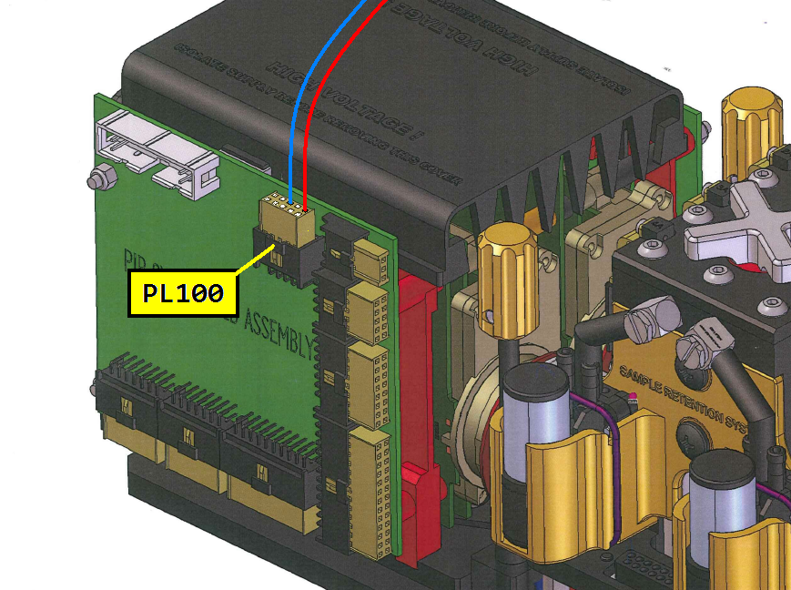

The hardware needed to connect to the System PCB is pictured below.

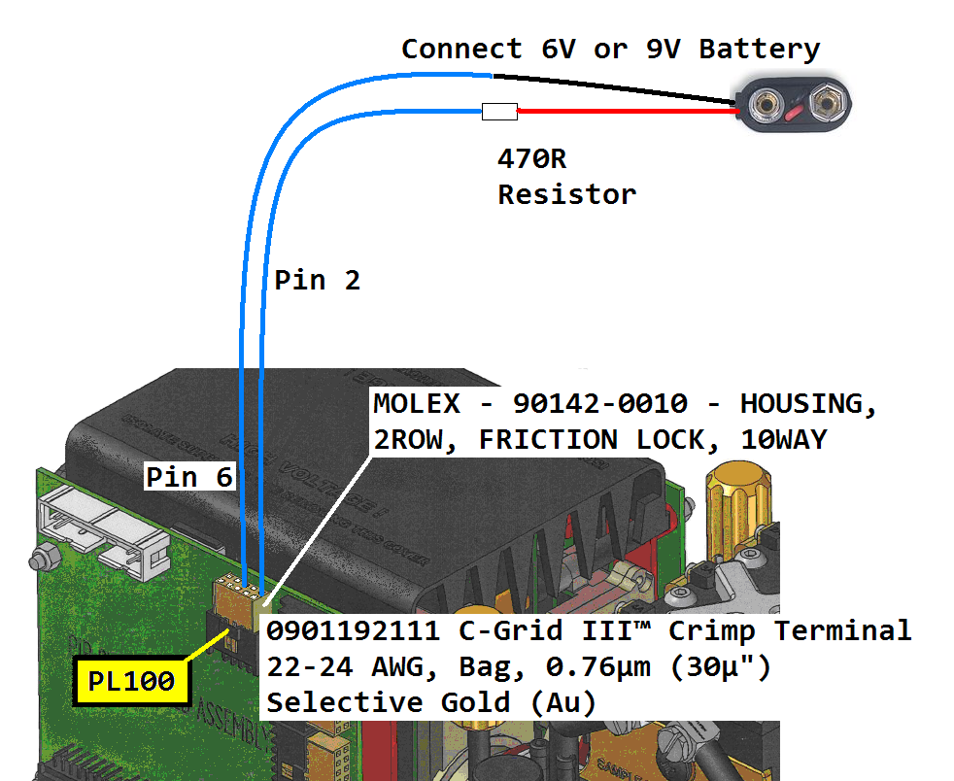

Now power up the ANACONDA. When the ANACONDA is powered up, the microcontroller bootloader will be invoked and the device will be ready to communicate with the programming application running on an external PC.

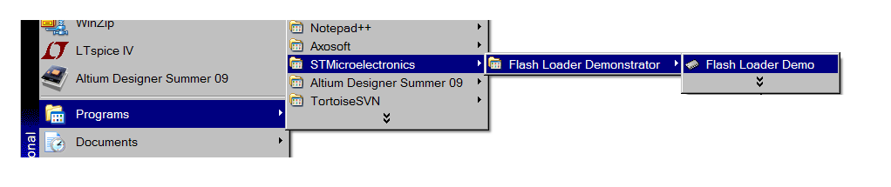

Start the application. Use the PC COM port of your choice but please use even parity, echo disabled and 5s timeout. The microcontroller's bootloader will automatically calculate the baudrate in use but 57600 is a good compromise between speed and serial transmission errors. If errors are encountered, try a slower speed.

The slowest supported speed is 1200 baud.

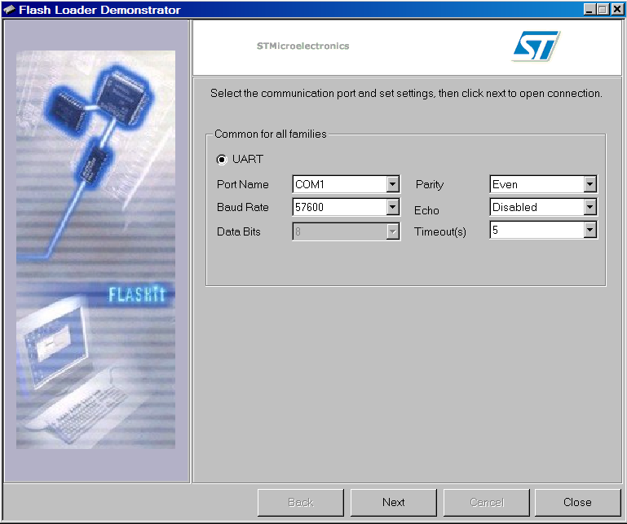

Click "Next".
If the bootloader was successfully invoked, the "Target is readable" screen will be displayed

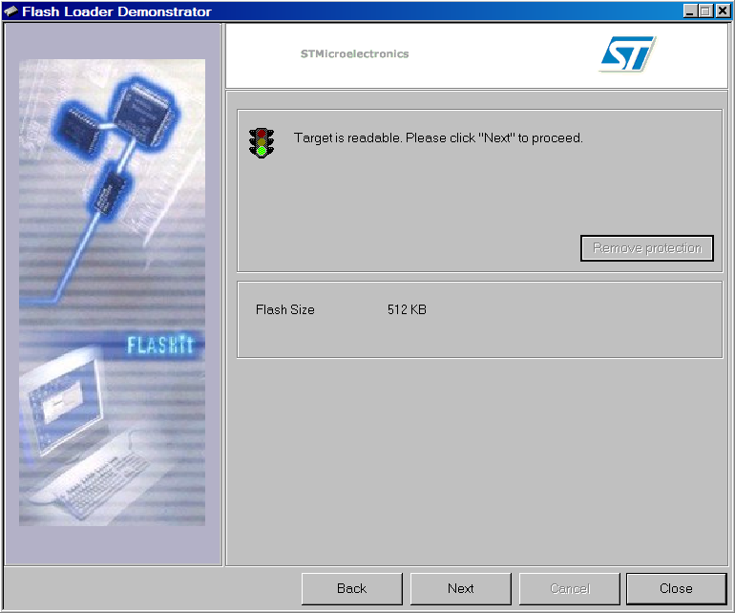

The STM32F103VET6 microcontroller used in the ANACONDA System and Display PCBs is a "High Density" device with 512K of EPROM. Check that the correct Target has been selected.

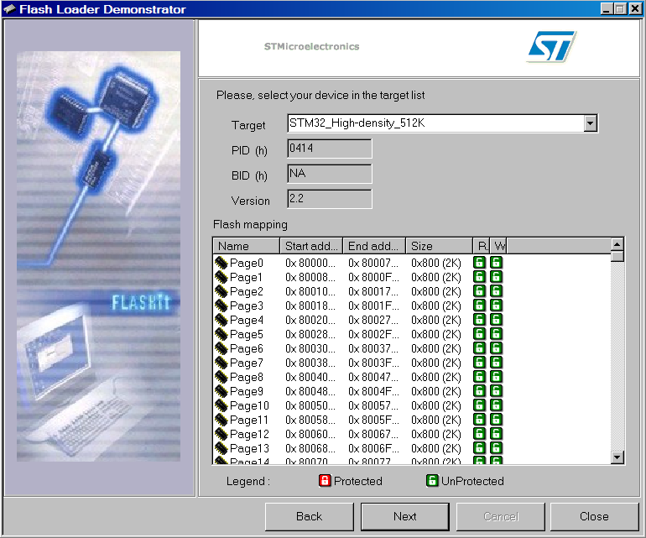

Click "Next".
Choose "Download to device" and "Erase necessary pages". Navigate to the required file " ANACONDASystem.hex" etc. Tick the "Verify after download" box.

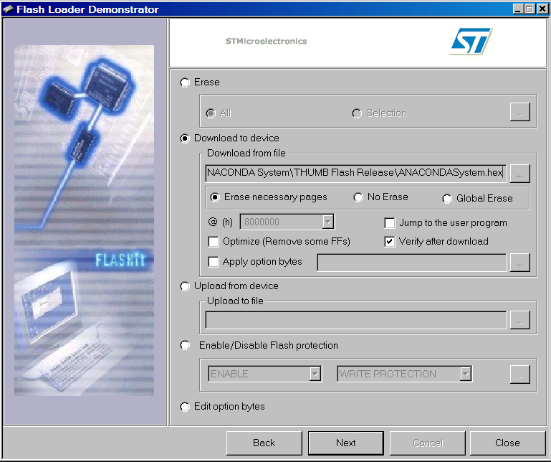

Click "Next".

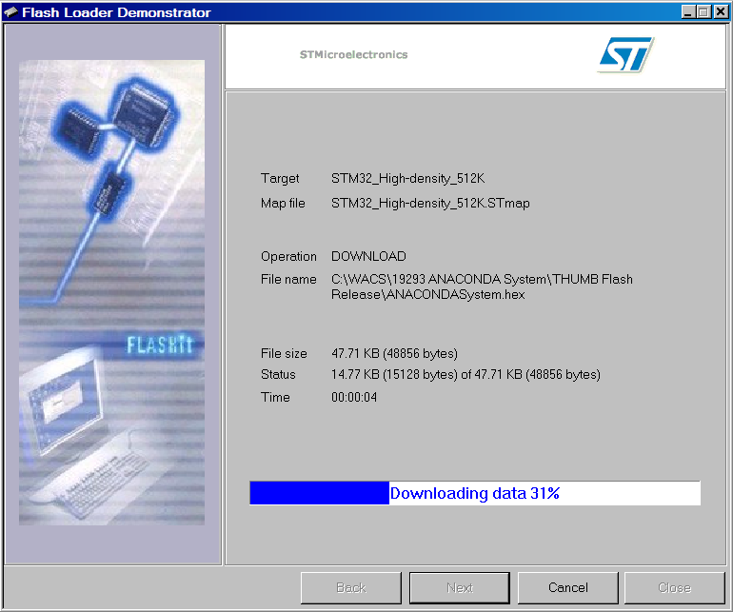

The file should download and verify.
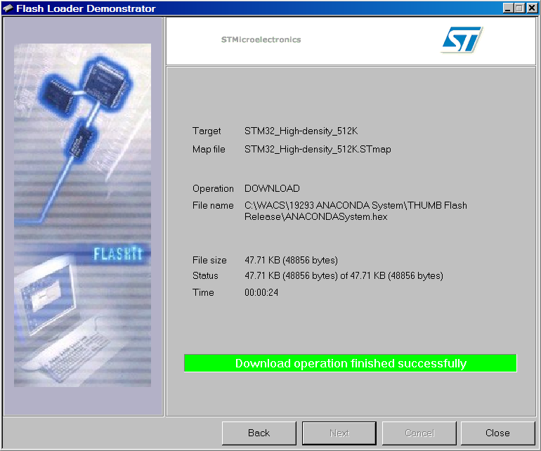

Click "Close".

Power down the ANACONDA and remove the +5V..+9V from PL100 pin 2.

Next time the ANACONDA is powered up, it should run normally executing the downloaded software.

Reprogramming the Display PCBs

The same programming application is used but bootloader invocation differs. No additional hardware connection is needed. If any connection has been made to PL100 on the System PCB, please remove it before proceeding.

Power up ANACONDA normally and start the "A-Link" application and establish communications with the ANACONDA.

The following two steps MUST be completed before LCDA or LCDB programming is possible.

Choose "Idle" mode.

Send the "Permit Debug" command, 62 (0x3E) DebugPermitDebug.

Then to reprogram LCD A, send command 82 (0x52)

or to reprogram LCD B, send command 83 (0x53).

These were the "DebugWriteTestFileLCDA/B" commands in A-Link 0.33 but may have been renamed to "Reprogram LCDA" and "Reprogram LCDB" for example in later A-Link versions.

When the command is actioned, the normal data from the ANACONDA will cease and LCD A or LCD B bootloader will be connected to the serial channel. LED D2 on the system PCB will illuminate and remain on.

Close A-Link without sending any other commands and start the Flash Loader Demonstrator program. Then proceed as above but loading the Display software.

When programming is complete, power down the ANACONDA.

Next time the ANACONDA is powered up, it should run normally.

